Kubernetes, also known as K8s, is an open-source container orchestration engine for automating deployment, scaling, and management of containerized applications. The open-source project is hosted by the Cloud Native Computing Foundation (CNCF)
Kubernetes is an open-source container management or container orchestration tool (platform) which automates container deployment, container (de)scaling and container load balancing.
Kubernetes is a portable, extensible, open source platform for managing containerized workloads and services that facilitate both declarative configuration and automation. It has a large, rapidly growing ecosystem. Kubernetes services, support, and tools are widely available.
It is a container orchestration technology used to orchestrate the deployment and management of hundreds and thousands of containers in a clustered environment.
Kubernetes provides a command line tool for communicating with a Kubernetes cluster's control plane, using the Kubernetes API. This tool is named kubectl (kube control).

Why you need Kubernetes and what it can do
Containers are a good way to bundle and run your applications. In a production environment, you need to manage the containers that run the applications and ensure that there is no downtime. For example, if a container goes down, another container needs to start. Wouldn't it be easier if this behavior was handled by a system?
That's how Kubernetes comes to the rescue! Kubernetes provides you with a framework to run distributed systems resiliently. It takes care of scaling and failover for your application, provides deployment patterns, and more. For example: Kubernetes can easily manage a canary deployment for your system.
Kubernetes Features:
- Service discovery and load balancing: No need to modify your application to use an unfamiliar service discovery mechanism. Kubernetes gives Pods their own IP addresses and a single DNS name for a set of Pods and can load-balance across them (If traffic to a container is high, Kubernetes is able to load balance and distribute the network traffic so that the deployment is stable). Service discovery in Google Kubernetes Engine (GKE) is the mechanism that allows applications and services inside a Kubernetes cluster to automatically find and communicate with each other using DNS names instead of hardcoded IP addresses. This ensures reliability and scalability, even when Pods are rescheduled or replaced.
- Storage orchestration: Kubernetes allows you to automatically mount a storage system of your choice, such as local storage, public cloud providers, or a network storage system such as iSCSI or NFS.
- Automated rollouts and rollbacks: Kubernetes progressively rolls out changes to your application or its configuration, while monitoring application health to ensure it doesn't kill all your instances at the same time. If something goes wrong, Kubernetes will rollback the change for you. Take advantage of a growing ecosystem of deployment solutions. For example, you can automate Kubernetes to create new containers for your deployment, remove existing containers and adopt all their resources to the new container.
- Automatic bin packing: You provide Kubernetes with a cluster of nodes that it can use to run containerized tasks. Automatically places containers based on their resource requirements and other constraints, while not sacrificing availability. You tell Kubernetes how much CPU and memory (RAM) each container needs. Kubernetes can fit containers onto your nodes to make the best use of your resources.
- Self-healing: Kubernetes restarts containers that fail, replaces containers, kills containers that don't respond to your user-defined health check, and doesn't advertise them to clients until they are ready to serve.
- Secret and configuration management: Kubernetes lets you store and manage sensitive information, such as passwords, OAuth tokens, and SSH keys. You can deploy and update secrets and application configuration without rebuilding your container images, and without exposing secrets in your stack configuration.
- Batch execution: In addition to services, Kubernetes can manage your batch and CI workloads, replacing containers that fail, if desired.
- Horizontal scaling: Scale your application up and down with a simple command, with a UI, or automatically based on CPU usage.
- Vertical scaling: Automatically adjust resource requests and limits based on actual usage patterns.
- IPv4/IPv6 dual-stack: Allocation of IPv4 and IPv6 addresses to Pods and Services
- Designed for extensibility: Add features to your Kubernetes cluster without changing upstream source code.

How Kubernetes helps with container orchestration
Kubernetes orchestration allows you to build application services that span multiple containers, schedule containers across a cluster, scale those containers, and manage their health over time.
Kubernetes eliminates many of the manual processes involved in deploying and scaling containerized applications. You can cluster together groups of hosts, either physical or virtual machines, running Linux containers, and Kubernetes gives you the platform to easily and efficiently manage those clusters.
More broadly, it helps you fully implement and rely on a container-based infrastructure in production environments. These clusters can span hosts across public, private, or hybrid clouds. For this reason, Kubernetes is an ideal platform for hosting cloud-native apps that require rapid scaling.
Kubernetes also assists with workload portability and load balancing by letting you move applications without redesigning them.

Key functions of Kubernetes orchestration
Kubernetes automates several critical functions that would otherwise require significant manual effort. These core capabilities are what make it such a powerful orchestration platform.
- Deployment: Kubernetes helps you describe the desired state for your deployed application. The orchestration engine then manages the rollout of changes, such as updating an application to a new version, in a controlled manner, often with zero downtime.
- Scaling: Based on CPU utilization or other custom metrics, Kubernetes can automatically scale the number of running containers up or down. This helps ensure that your application has the resources it needs to handle load while optimizing for cost.
- Self-healing: If a container or a node fails, Kubernetes orchestration can automatically detect the failure. It will then restart, replace, or reschedule containers on healthy nodes to help ensure the application remains available without manual intervention.
- Service discovery and load balancing: Kubernetes can automatically expose a container to the internet or other containers in the cluster using a stable DNS name. It can also load-balance traffic across multiple containers that provide the same service, to ensure requests are distributed efficiently.
- Configuration management: Kubernetes lets you store and manage sensitive information, such as passwords and API keys, as "Secrets." It also handles application configuration data as "ConfigMaps," so you can update configurations without rebuilding your container images.

Benefits of kubernetes container orchestration
One of the biggest benefits of container orchestration is that it simplifies operations. Automating tasks not only helps to minimize the effort and complexity of managing containerized apps, it also translates into many other advantages.
Reliable application development: Container orchestration tools help make app development faster and repeatable. This increases deployment velocity and makes them ideal for supporting agile development approaches like DevOps.
Scalability: Container orchestration allows you to scale container deployments up or down based on changing workload requirements. You also get the scalability of cloud if you choose a managed offering and scale your underlying infrastructure on demand.
Lower costs: Containers require fewer resources than virtual machines, reducing infrastructure and overhead costs. In addition, container orchestration platforms require less human capital and time, yielding additional cost savings.
Enhanced security: Container orchestration allows you to manage security policies across platforms and helps reduce human errors that can lead to vulnerabilities. Containers also isolate application processes, decreasing attack surfaces and improving overall security.
High availability: It’s easier to detect and fix infrastructure failures using container orchestration tools. If a container fails, a container orchestration tool can restart or replace it automatically, helping to maintain availability and increase application uptime.
Better productivity: Container orchestration boosts developer productivity, helping to reduce repetitive tasks and remove the burden of installing, managing, and maintaining containers.

Container Orchestration (Container Management):
Now we have our application packaged into a Docker container. But what's next? How do you run it in production? What if your application relies on other containers, such as databases or messaging services or other backend services? What if the number of users increases you need to scale your application? How do you scale down when the load decreases? To enable these functionalities, you need an underlying platform with a set of resources and capabilities. The platform needs to orchestrate the connectivity between the containers and automatically scale up or down based on the load. This whole process of automatically deploying and managing containers is known as container orchestration.
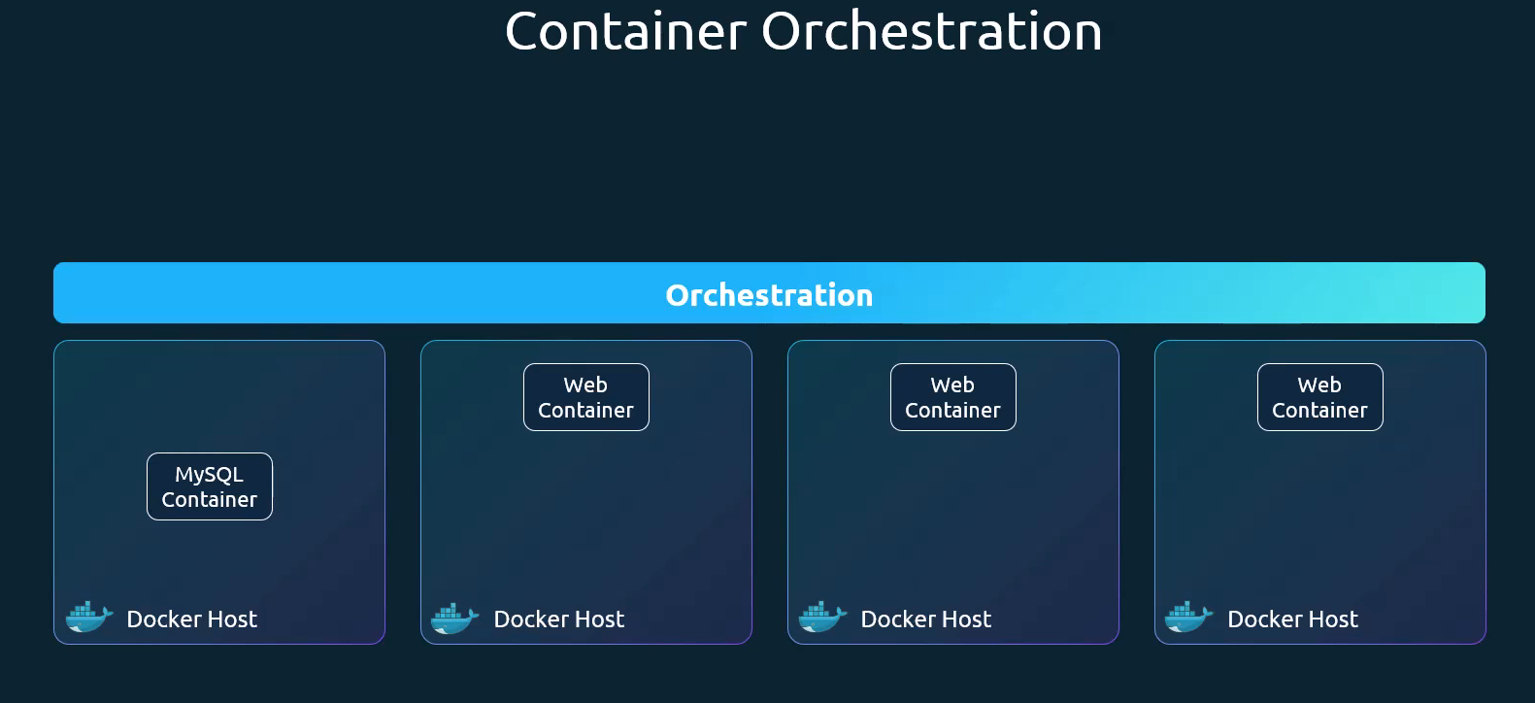
Managing a single containerized application is relatively straightforward, but scaling to hundreds or thousands across a distributed system introduces significant challenges in ensuring availability, interconnectivity, and scalability. Container orchestration addresses these complexities.
Container orchestration is the system that automatically provisions, deploys, scales, and manages containerized applications without worrying about the underlying infrastructure.
Container orchestration is a software technology that allows the automatic management of containers. This is necessary for modern cloud application development because an application might contain thousands of microservices in their respective containers. The large number of containerized microservices makes it impossible for software developers to manage them manually.
Container orchestration is the process of automating the deployment, management, scaling, and networking of containers throughout their lifecycle, making it possible to deploy applications consistently across many different environments at scale. Containerization bundles an application’s code with all the files and libraries it needs to run on any infrastructure. Microservices architectures can have hundreds, or even thousands, of containers as applications grow and become more complex. Container orchestration tools aim to simplify container infrastructure management by automating their complete lifecycle—from provisioning and scheduling to deployment and deletion. Organizations can benefit from containerization at scale without incurring additional maintenance overheads. Tools to manage, scale, and maintain containerized applications are called orchestrators. Two of the most popular orchestration tools are Kubernetes and Docker Swarm. Kubernetes is just a container orchestration technology. There are multiple such technologies available today. Docker has its own tool called Docker Swarm, Kubernetes from Google and Mesos from Apache.
While Kubernetes is the leading open-source platform for this task, fully managed container orchestration tools, like Google Kubernetes Engine (GKE), simplify the deployment and ongoing management, abstracting away much of the operational burden associated with Kubernetes. Today, Kubernetes is the most popular container orchestration platform, and most leading cloud service providers—including Amazon Web Services (AWS), Google Cloud Platform, IBM Cloud® and Microsoft Azure—offer managed Kubernetes services. Other container orchestration tools include Docker Swarm and Apache Mesos.

Popular Tools: Kubernetes, Docker Swarm, Apache Mesos, OpenShift, GitLab, Spacelift, Rancher
- Kubernetes (K8s): The industry standard, powerful and feature rich
- Docker Swarm: Simpler, integrated with Docker
- Apache Mesos: A distributed systems kernel for large-scale clusters

Why is container orchestration necessary?
Containers have become the standard unit of computing for cloud-native applications. Cloud providers offer virtual server instances for running all sorts of computing workloads, and are a perfect fit for container-based workloads. The only requirement to be able to run containers is that the server itself runs a containerization service like Docker. Docker is an open source tool for packaging software and associated libraries, system tools, code, and runtime into a container. It is a lightweight solution for running and managing a few containers on a single server instance, but scaling becomes a challenge.
Before managed container orchestration platforms existed, organizations used complex scripting to manage container deployment, scheduling, and deletion across multiple machines. Maintaining these scripts created challenges, like version control, and setup was difficult to scale. Container orchestration automates and resolves these complexities, removing challenges associated with manual management.

Container orchestration use cases
Container orchestration tools become necessary when you have to:
- Manage and scale containers across a number of instances.
- Run many different containerized applications.
- Run different versions of applications (for example, test and production across CI/CD) at once.
- Ensure app service continuity in case of a server failure by running multiple duplicate instances (replicas) of a container.
- Run multiple instances of an app across multiple different geographical regions.
- Maximize usage of multiple server instances for budgeting purposes.
- Run large containerized applications comprised of thousands of different microservices.

What is container orchestration used for?
Use container orchestration to automate and manage tasks such as:
- Provisioning and deployment
- Configuration and scheduling
- Resource allocation
- Container availability
- Scaling or removing containers based on balancing workloads across your infrastructure
- Load balancing and traffic routing
- Monitoring container health
- Configuring applications based on the container in which they will run
- Keeping interactions between containers secure

What are the benefits of container orchestration?
Managing complex container architectures without a container orchestration solution can be difficult. Developers use container orchestration tools to automatically start, stop, and manage containers. Container orchestrators allow developers to scale cloud applications precisely and avoid human errors. For example, you can verify that containers are deployed with adequate resources from the host platform. Container orchestration manages container creation, configuration, scheduling, deployment, and deletion. It also supports:
- Application load balancing and traffic management.
- App service continuity across containers.
- Security across containerization.
- Container status monitoring.
- Resourcing containers from underlying server or instance resources.
The following are more benefits of container orchestrations.
Built-in resilience
Simple containerization services typically will not restart a container if it goes offline. Similarly, if the machine that a container is running on goes down, the container won’t be restarted when the machine restarts. Container orchestration solutions can ensure that containers are automatically restarted or that more than one version is running at all times in case of machine failure.
Enhanced performance
One of the biggest benefits of container orchestration is that it automates the scalability, availability, and performance of containerized apps. You can configure container orchestration tools to scale based on demand, network availability, and infrastructure restrictions. The container orchestration solution can monitor performance across the container network and automatically reconfigure containers for optimal performance.
Resource optimization
Underlying servers and instances cost money to run and must be used efficiently for cost optimization. Container orchestration allows organizations to maximize the usage of each available instance, as well as instantiate on-demand instances if resources run out. This leads to cost savings in infrastructure.

How does container orchestration work?
Containers are self-contained Linux-based applications or microservices bundled with all the libraries and functions they need to run on almost any type of machine. Container orchestration works by managing containers across a group of server instances (also called nodes). A group of nodes that runs interconnected containers is called a cluster.
Container orchestration requires, first, an underlying containerization solution running on every node in the cluster—typically, this will be Docker. The nodes must also run the orchestration tool. A designated master node, with a control plane, is the controller of the orchestration solution itself. The administrator of the solution uses a GUI or command-line controller on the master node to manage and monitor the container orchestration tool.
Creation and scheduling
The container orchestration solution reads a declarative configuration file, written in YAML or JSON, to learn the specific required state of the system. Using the information specified in the file, the tool:
- Obtains container images from a container registry.
- Provisions the containers with their individual requirements.
- Determines the networking required between the containers.
The tool then schedules and deploys the multi-container application across the cluster. This best fit between nodes and containers is determined by the container orchestration tool, rather than specified in the configuration file. The tool selects the actual node to run each container based on the node’s resource constraints, such as CPU, memory, and so on, as well as the defined container requirements.
Management
Once the containers are running across the cluster, the orchestration tool manages overall system health to ensure it remains in the specified performance state. This may include:
- Resource allocation across containers.
- Deploying containers to new nodes or deleting containers.
- Load balancing of traffic to the application.
A container orchestration solution manages the lifecycle of containers to optimize and secure large, complex multi-container workloads and environments. It can manage as many containerized applications as an organization requires. Running multiple master nodes for high availability and fault tolerance is typical under higher organizational demands.

Core Components of Kubernetes Cluster (Kubernetes Architecture)
A Kubernetes cluster consists of a control plane (master node) and one or more worker nodes.
- Control plane (Master Node): The control plane is the brain of the Kubernetes cluster. It makes all global decisions about the cluster (like scheduling) and is responsible for detecting and responding to cluster events to maintain the user's desired state. Control plane is the central management entity of the Kubernetes cluster, responsible for maintaining the desired state of cluster. The master is another node with Kubernetes installed in it and is configured as a master. The master watches over the nodes in the cluster and is responsible for the actual orchestration of containers on the worker nodes.
- Worker Node (Node): A node is a single worker machine within the cluster, either a physical server or a virtual machine on which Kubernetes is installed . Every cluster needs at least one worker node in order to run pods. A node is a worker machine and it is the place where containers will be launched by Kubernetes. But what if the node on which your application is running fails? Well, obviously our application goes down, so you need to have more than one node.
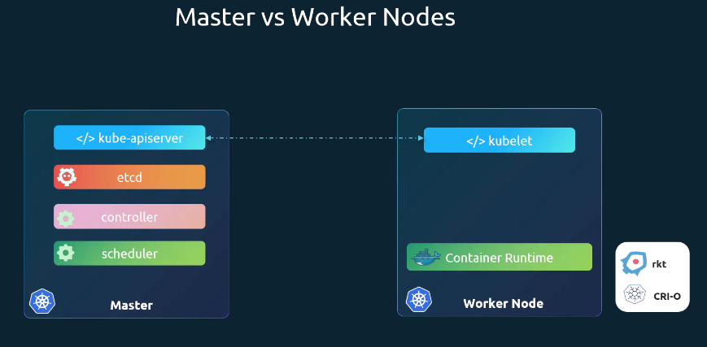

When you install Kubernetes on a system, you're actually installing the following components
API server (kube apiserver): The API server acts as the front end for Kubernetes. The user's management devices, command line interfaces all talk to the API server to interact with the Kubernetes cluster.
etcd: Etcd is a distributed, reliable key value store used by Kubernetes to store all data used to manage the cluster.
Scheduler (kube-scheduler): the scheduler is responsible for distributing work or containers across multiple nodes. It looks for newly created containers and assigns them to nodes.
Controller (kube-controller-manager): The controllers are the brain behind Kubernetes orchestration. Kubernetes controllers act as the control plane’s “brain,” continuously observing cluster objects and reconciling the current state with your declared desired state. They are the processes that monitor Kubernetes objects and respond accordingly. They're responsible for noticing and responding when nodes, containers, or endpoints goes down. In Kubernetes, controllers are control loops that watch the state of your cluster, then make or request changes where needed. Each controller tries to move the current cluster state closer to the desired state. A Kubernetes controller is a non-terminating control loop that regulates the state of a system by constantly comparing the current cluster state (via the API server) with the desired state. If a discrepancy exists, it acts to reconcile the two, ensuring self-healing actions like restarting, scaling, or updating pods. Kubernetes controllers are core components in Kubernetes that continuously monitor and maintain the desired state of your cluster. For e.g. Node controller, Job controller, Deployment controller, service account controller etc.
Container runtime: Container runtime is the underlying software that is used to run containers such as docker, containerd, CRI-O, podman etc. Docker was the original and only supported container runtime for Kubernetes, and to make Kubernetes open to other runtimes, we had the container runtime interface introduced. The CRI is a plugin interface which enables the kubelet to use a wide variety of container runtimes, without having a need to recompile the cluster components. You need a working container runtime on each Node in your cluster, so that the kubelet can launch Pods and their containers. The Container Runtime Interface (CRI) is the main protocol for the communication between the kubelet and Container Runtime. The Kubernetes Container Runtime Interface (CRI) defines the main gRPC protocol for the communication between the node components kubelet and container runtime. CRI allowed any vendor to work as a container runtime for Kubernetes as long as they adhere to the OCI standards. So OCI stands for Open Container Initiative, and it consists of an imagespec and a runtimespec. Image spec means the specifications on how an image should be built and the runtime spec defines the standards on how any container runtime should be developed.
Docker consisted of multiple tools put together like docker CLI, the API, the build tools that help build images. There was support for volumes, auth, security and finally also the container runtime called runc and the daemon that managed the runtime called the containerd. So, containerd is the CLI compatible and that's the component that can work directly with Kubernetes as all of the other runtimes. So, containerd can be used as a runtime on its own separate from Docker.
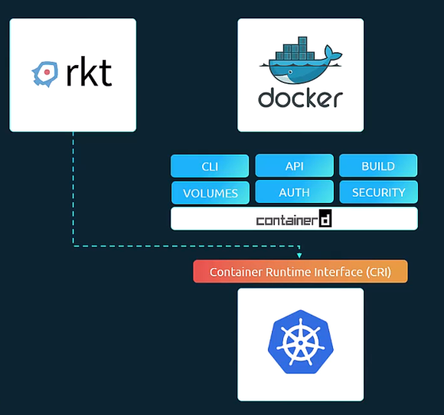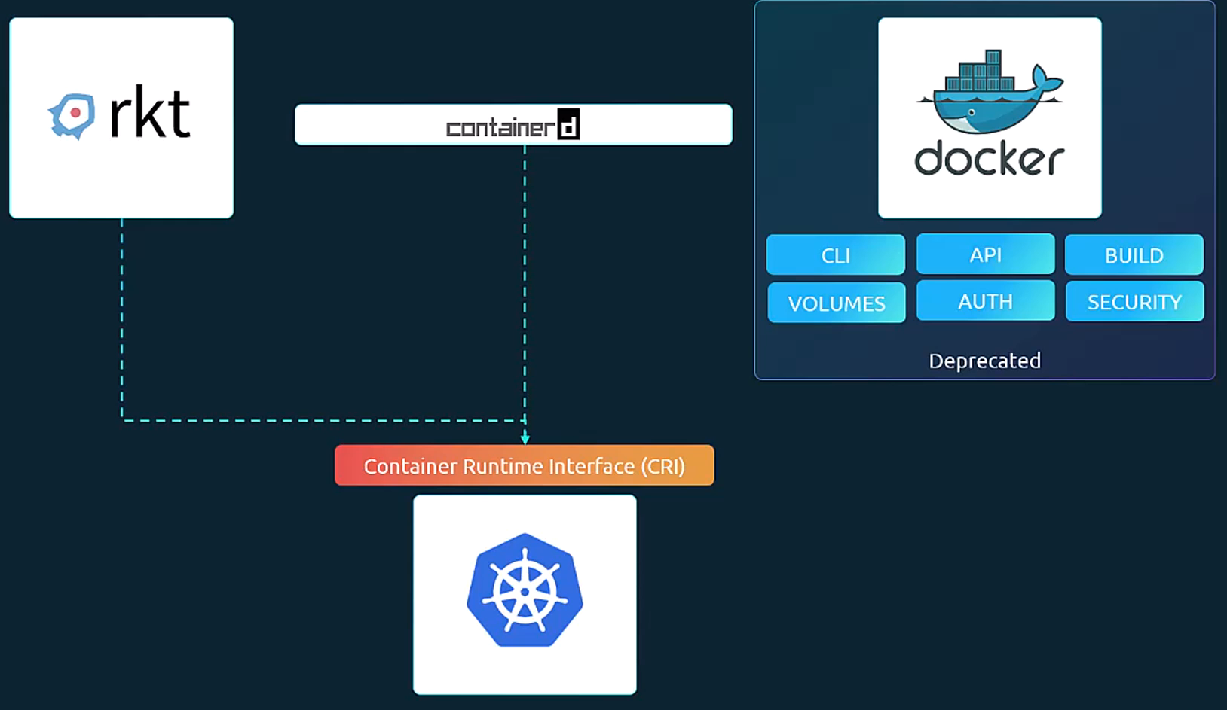
So, once this change was made, Kubernetes no longer needed. The other tools that Docker supported like Docker CLI, the API, build tool, volumes etc. as they were all taken care of by Kubernetes itself. And so, Kubernetes was able to deprecate the support for Docker. Now that doesn't mean that Docker is entirely gone. So, Docker is still the most popular container solution out there and used by many in their day-to-day development and build processes. It's just that Kubernetes no longer required Docker as the runtime.
Kubelet: Kubelet is the agent that runs on each node in the cluster. The agent is responsible for making sure that the containers are running on the nodes as expected. The kubelet doesn't manage containers which were not created by Kubernetes. The worker nodes have the Kubelet agent that is responsible for interacting with the master to provide health information of the worker node and carry out actions requested by the master on the worker nodes.
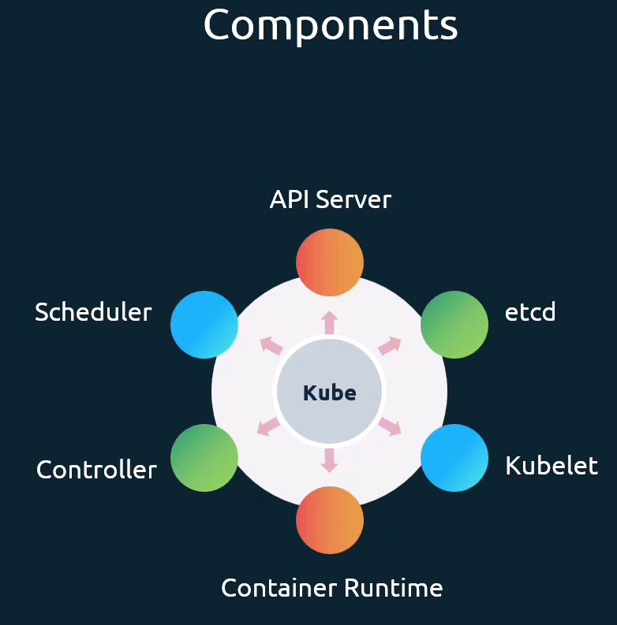
kubectl: Kubernetes provides a command line tool for communicating with a Kubernetes cluster's control plane, using the Kubernetes API. This tool is named kubectl or kube control. kubectl controls the Kubernetes cluster manager. The Kubernetes command-line tool, kubectl, allows you to run commands against Kubernetes clusters. You can use kubectl to deploy applications, inspect and manage cluster resources, and view logs. The kubectl run command is used to deploy an application on the cluster. The kubectl cluster info command is used to view information about the cluster and the kubectl get nodes command is used to list all the nodes part of the cluster.
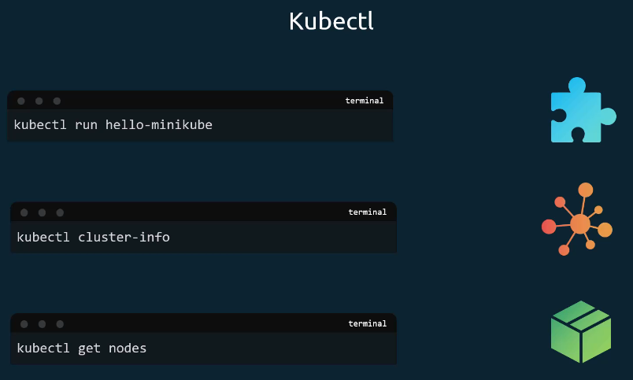

crictl: The CRI control (crictl) is a command line utility that is used to interact with the CRI compatible container runtime. So, this is kind of an interaction from the Kubernetes perspective. So, this tool is developed and maintained by the Kubernetes community. And this tool works across all the different container runtimes. So, it must be installed separately. And it is used to inspect and debug container runtime. So, this again is not ideally used to create containers unlike docker command.
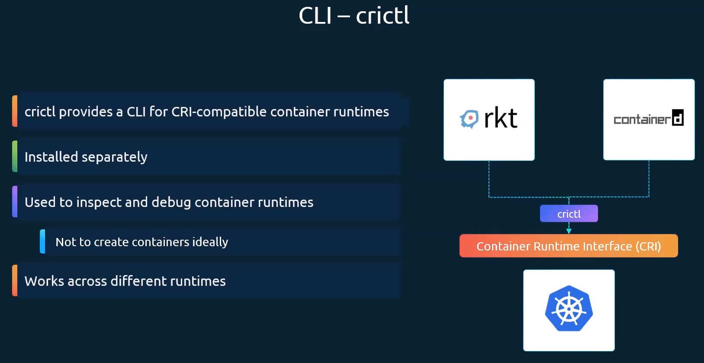
Key concepts of Kubernetes orchestration
Kubernetes orchestration works by managing a cluster of machines and deploying containers onto them based on the resources they require and the desired state defined by the user. The system is made up of several key concepts that work together.
- Cluster: This is the set of all machines, known as nodes, that are grouped together and managed by Kubernetes to run your applications. A cluster is a set of nodes grouped together. This way, even if one node fails, you have your application still accessible from the other nodes. Moreover, having multiple nodes helps in sharing load as well.
Cluster modes: Google Kubernetes Engine (GKE) offers two primary operational modes: Autopilot and Standard. Autopilot is a fully managed, hands-off experience where Google manages the underlying infrastructure and scales your nodes automatically. Standard mode gives you granular administrative control over your node pools, VMs, and configurations.
- Node: A node in Kubernetes is a single machine—either virtual or physical—that provides the actual computing power for your cluster. A node is a worker machine that runs your containerized applications. These nodes are the workhorses of your cluster, providing the actual CPU and memory resources required to execute your workloads.

- Pods: Pods are the smallest deployable units of computing that you can create and manage in Kubernetes, representing a single instance of a running application. They contain one or more containers, shared storage, and a unique network IP. A pod is the smallest object that you can create in Kubernetes. Pods usually have a 1 to 1 relationship, with containers running your application. To scale up your application, you create new pods, and to scale down your application you delete existing pods. You do not add additional containers to an existing pod to scale your application. A single pod can have multiple containers, except for the fact that they're usually not multiple containers of the same kind. A pod hosts a container.
- Containers: These are the lightweight, portable, and executable packages that contain an application and all of its dependencies. Kubernetes orchestrates the deployment and life cycle of these containers. However, Kubernetes does not deploy containers directly on the worker nodes. The containers are encapsulated into a Kubernetes object known as pods. Each container is encapsulated in pod.
- Node pool: A node pool is a group of nodes within a Standard cluster that all have the same configuration. In GKE Standard mode, you can choose from a number of options for your node pools to meet your workload needs. If you choose to use Autopilot, you don't need to configure node pools: GKE manages the nodes for you, although you can manually upgrade Autopilot-managed node pools in Standard clusters if needed. A node pool is a group of nodes within a cluster that all have the same configuration. Node pools use a NodeConfig specification.
In Google Kubernetes Engine (GKE), a node pool is a group of nodes within a Standard cluster that share the exact same configuration (machine type, image, disk type). They allow you to easily run workloads with diverse requirements, such as specialized GPU processing or heavy memory, within a single cluster.

Key Concepts and Features
- Identical Configurations: Every node in a specific pool has identical specifications and carries the same Kubernetes label (cloud.google.com/gke-nodepool).
- Independent Management: You can create, resize, upgrade, and delete node pools individually without disrupting the rest of the cluster.
- Pod Placement Control: Use nodeSelector or nodeAffinity rules in your Pod manifests to force specific workloads to deploy onto nodes within a particular pool.
- Upgrades: Node pools can be upgraded automatically or manually, using strategies like surge upgrades (speed) or blue-green upgrades (risk mitigation).

When to use custom node pools
You can tailor node pools for specific infrastructure demands, such as: []
- Hardware Requirements: Creating specific pools for Spot VMs, local SSDs, or instances with attached GPUs.
- Resource Scaling: Adding pools of larger machine types to handle applications that are memory or CPU intensive.
- Isolation: Isolating certain workloads to prevent them from taking up resources needed for critical core services.
GKE Autopilot vs. Standard
- Standard Clusters: You fully manage your node pools, including choosing machine types, scaling sizes, and scheduling upgrades.
- Autopilot Clusters: Node pools are completely managed and provisioned by Google, relieving you from having to define or manage the underlying nodes yourself.

Kubernetes Operator
Operators are software extensions to Kubernetes that make use of custom resources to manage applications and their components. Operators follow Kubernetes principles, notably the control loop
A Kubernetes operator is an application-specific controller that extends the functionality of the Kubernetes API to create, configure, and manage instances of complex applications on behalf of a Kubernetes user.
It builds upon the basic Kubernetes resource and controller concepts, but includes domain or application-specific knowledge to automate the entire life cycle of the software it manages.
Kubernetes Operators are software extensions that automate the management of complex, stateful applications by extending the Kubernetes API and encapsulating human operational knowledge in code. They are essentially application-specific controllers that continuously monitor and reconcile the application's actual state with a desired state defined by a user in a custom resource.
In Kubernetes, controllers of the control plane implement control loops that repeatedly compare the desired state of the cluster to its actual state. If the cluster's actual state doesn’t match the desired state, then the controller takes action to fix the problem.
An operator is a custom Kubernetes controller that uses custom resources (CR) to manage applications and their components. High-level configuration and settings are provided by the user within a CR. The Kubernetes operator translates the high-level directives into the low level actions, based on best practices embedded within the operator’s logic.
A custom resource is the API extension mechanism in Kubernetes. A custom resource definition (CRD) defines a CR and lists out all of the configuration available to users of the operator.
The Kubernetes operator watches a CR type and takes application-specific actions to make the current state match the desired state in that resource.
Kubernetes operators introduce new object types through custom resource definitions. Custom resource definitions(CRD) can be handled by the Kubernetes API just like built-in objects, including interaction via kubectl and inclusion in role-based access control (RBAC) policies.
A Kubernetes operator continues to monitor its application as it runs, and can back up data, recover from failures, and upgrade the application over time, automatically.
The actions a Kubernetes operator performs can include almost anything: scaling a complex app, application version upgrades, or even managing kernel modules for nodes in a computational cluster with specialized hardware. For e.g MySQL operator, Argo CD operator, PostgreSQL Operator, Airflow Helm Operator etc. You can explore and install a wide range of Kubernetes Operators by visiting the OperatorHub at https://operatorhub.io/

Kubernetes Controller Vs Kubernetes Operator
An Operator is a specialized type of Kubernetes controller that uses custom resources (CRDs) to manage complex, application-specific tasks and encode human operational knowledge into software. A generic Kubernetes controller, by contrast, manages only the built-in, native Kubernetes resources.
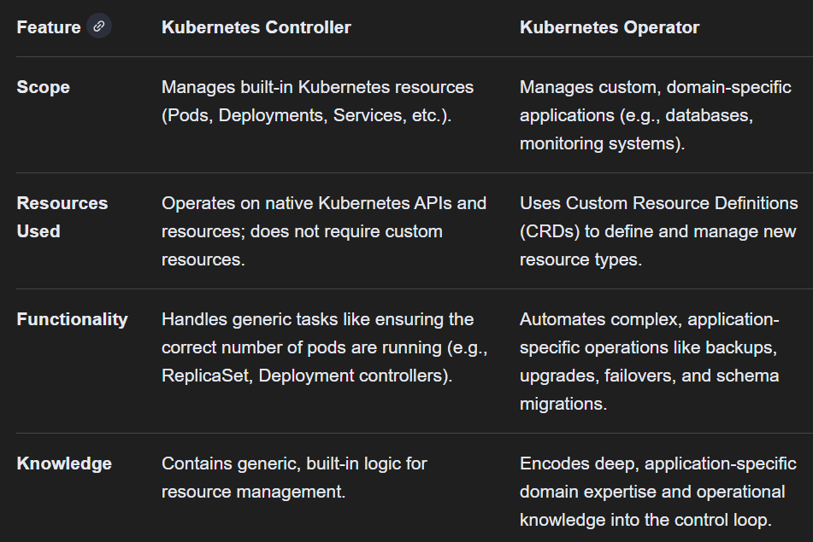
Kubernetes Controllers are ideal for managing stateless apps and maintaining the correct number of copies, but Kubernetes Operators are more appropriate for complicated, stateful applications that require human-like decision-making abilities. Kubernetes operators provide a more specific approach to resource management, enabling users to enhance Kubernetes capabilities via Custom Resource Definitions.
Deployments
A Deployment manages a set of Pods to run an application workload, usually one that doesn't maintain state. A Deployment provides declarative updates for Pods and ReplicaSets. You describe a desired state in a Deployment, and the Deployment Controller changes the actual state to the desired state at a controlled rate. You can define Deployments to create new ReplicaSets, or to remove existing Deployments and adopt all their resources with new Deployments. In Kubernetes a deployment is a method of launching a pod with containerized applications and ensuring that the necessary number of replicas is always running on the cluster.
A Kubernetes Deployment is a high-level resource object that provides declarative updates for applications, managing the lifecycle of Pods and ReplicaSets to ensure a desired state of application availability and scaling. When you create a Deployment, Kubernetes automatically creates and manages ReplicaSets for you. Kubernetes Deployments automate application upgrades, scaling, and self-healing in production environments. They enable rolling updates, controlled rollbacks, and pause/resume capabilities—all without downtime.
The following are typical use cases for Deployments:
- Create a Deployment to rollout a ReplicaSet. The ReplicaSet creates Pods in the background. Check the status of the rollout to see if it succeeds or not.
- Declare the new state of the Pods by updating the PodTemplateSpec of the Deployment. A new ReplicaSet is created, and the Deployment gradually scales it up while scaling down the old ReplicaSet, ensuring Pods are replaced at a controlled rate. Each new ReplicaSet updates the revision of the Deployment.
- Rollback to an earlier Deployment revision if the current state of the Deployment is not stable. Each rollback updates the revision of the Deployment.
- Scale up the Deployment to facilitate more load.
- Pause the rollout of a Deployment to apply multiple fixes to its PodTemplateSpec and then resume it to start a new rollout.
- Use the status of the Deployment as an indicator that a rollout has stuck.
- Clean up older ReplicaSets that you don't need anymore.

Why Use a Deployment?
- Rolling Updates: Replace pods one by one to avoid service interruption.
- Rollbacks: Instantly revert to a previous version if something goes wrong.
- Pause & Resume: Apply several changes as a batch and resume when ready.
- Declarative Scaling: Increase or decrease replicas in your manifest.
How Deployments Work
A Deployment sits above ReplicaSets and Pods:
- Pod: The basic execution unit (one or more containers).
- ReplicaSet: Ensures a specified number of pod replicas run at any time.
- Deployment: Manages ReplicaSets and orchestrates updates, rollbacks, and scaling.
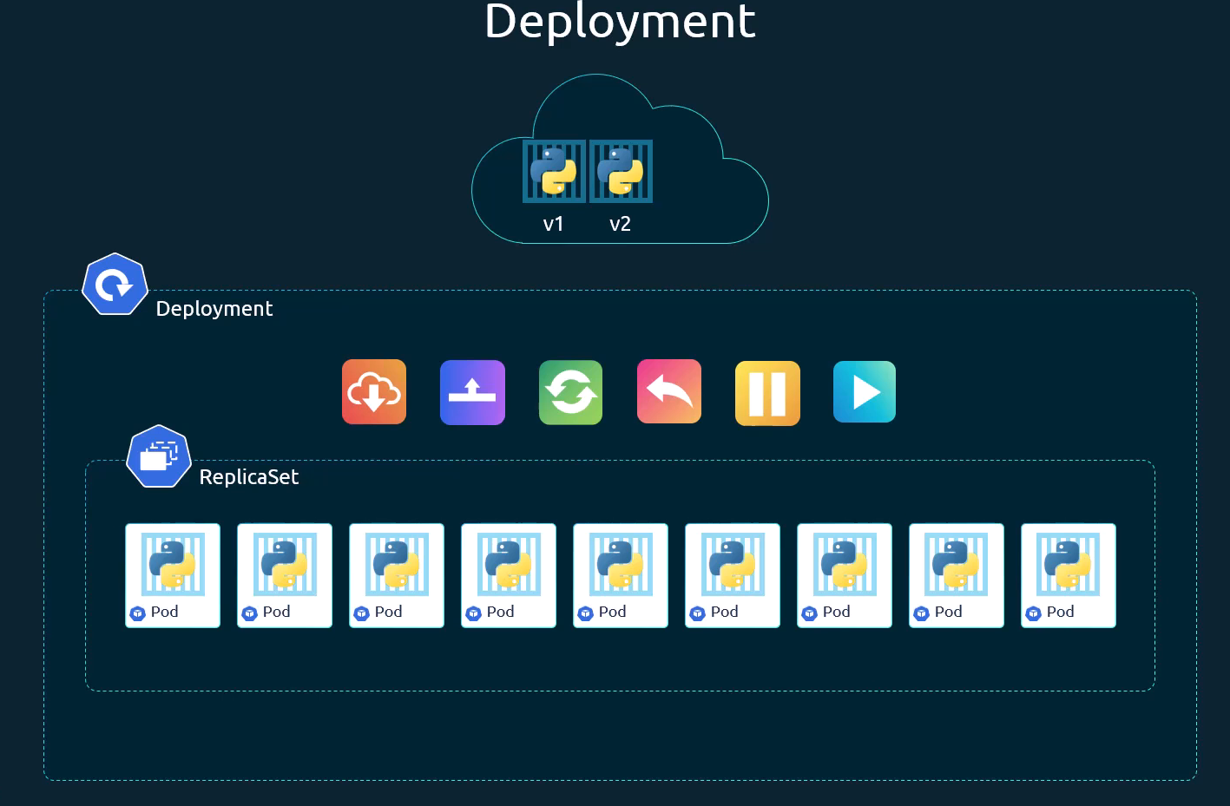

Resource Comparison
Resource Type | Purpose | Example Command
Pod | Single instance of one or more containers | kubectl run nginx --image=nginx
ReplicaSet | Maintains desired pod replicas | kubectl create -f replicaset-definition.yml
Deployment | Declarative updates and rollbacks | kubectl apply -f deployment-definition.yml
Creating a Deployment
The following is an example of a Deployment. It creates a ReplicaSet to bring up three nginx Pods:
nginx-deployment.yaml
apiVersion: apps/v1
kind: Deployment
metadata:
name: myapp-deployment
labels:
app: myapp
spec:
replicas: 3
selector:
matchLabels:
app: myapp
template:
metadata:
labels:
app: myapp
spec:
containers:
- name: nginx-container
image: nginx
ports:
- containerPort: 80

- apiVersion: The API group (apps/v1).
- kind: Must be Deployment.
- metadata: Identifies the Deployment (name and labels).
- spec.replicas: Desired number of pods.
- spec.selector: Matches labels on pods.
- spec.template: Defines the pod spec, just like a ReplicaSet.
A Deployment named myapp-deployment is created, indicated by the metadata.name field. This name will become the basis for the ReplicaSets and Pods which are created later. The Deployment creates a ReplicaSet that creates three replicated Pods, indicated by the spec.replicas field. The spec.selector field defines how the created ReplicaSet finds which Pods to manage. In this case, you select a label that is defined in the Pod template (app: myapp).

1) Create the Deployment by running the following command
>> kubectl apply -f nginx-deployment.yaml
2) Run kubectl get deployments command to check if the Deployment was created.
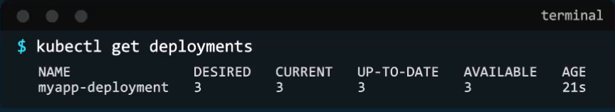
3) The deployment automatically creates a replica set. So, if you run the kubectl get replicaset command, you will be able to see a new replica set in the name of the deployment.
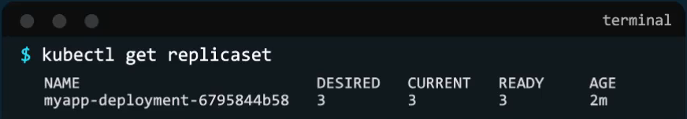
4) The replica sets ultimately create pods. So, if you run the kubectl get pods command, you will be able to see the pods with the name of the deployment and the replica set.
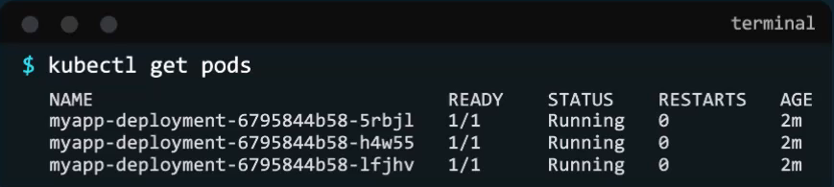
5) To see all the created objects at once, run the kubectl get all command. In this case we can see that the deployment was created and then we have the replica set followed by three pods that we created as part of the deployment. (**Note** In the current (default) namespace, there is no need to use -n <namespace-name> after each kubectl command)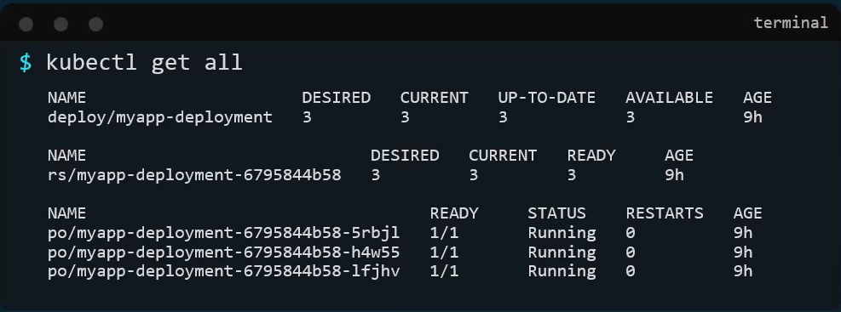
6) Create a new Deployment with the below attributes. Name: httpd-frontend; Replicas: 3; Image: httpd:2.4-alpine (You can create the Deployment either by defining a YAML file or by executing the command shown below.)
>> kubectl create deployment httpd-frontend --image= httpd:2.4-alpine –replicas=3
Deployment Strategies
Deployment strategies are techniques used to roll out changes to an application or system while minimizing downtime and risk. Deployment strategies are methods for releasing new software versions into production while minimizing downtime, risk, and user impact. There are several deployment strategies, each with its unique benefits and use cases.
Blue-Green Deployment
Blue-Green Deployment involves running two identical environments — one is the “Blue” (currently live) version, and the other is the “Green” (new) version. The transition from the Blue to Green environment is done in one swift move, reducing downtime significantly. If any issues arise during the deployment, you can quickly roll back to the stable Blue environment. Both the old ("blue") and new ("green") versions run simultaneously. Once the new version is tested and validated, traffic is switched instantly to the new version, allowing for immediate cutover and easy rollback.
Canary Deployment
Canary Deployment is a phased rollout strategy where a new version is released to a subset of users or servers before being made available to everyone. This approach allows early detection of potential issues and mitigates risks by limiting the blast radius of the deployment. A new version is released to a small subset of users first. Based on performance and user feedback, the rollout is gradually expanded to the entire user base. This minimizes the blast radius of failures.
Rolling Updates (Default)
Rolling Updates involve gradually replacing instances of the old version with instances of the new version without application downtime, ensuring high availability. This strategy ensures that a portion of your application is always running during the deployment process, minimizing downtime. Remember, if you do not specify a strategy while creating the deployment, it will assume it to be rolling update. It is the default deployment strategy and most common approach
Recreate Deployment (Big Bang)
This strategy terminates the old version instances completely before launching the new version instances. This causes temporary downtime but is simple and ensures no mixed-version issues. It results in downtime and is generally used in development environments or when application downtime is acceptable.
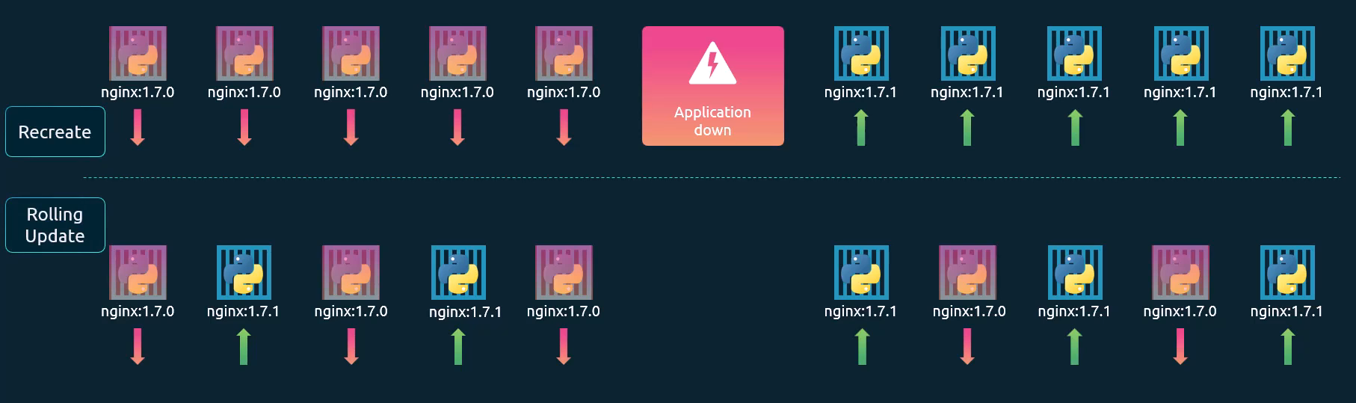
The difference between the Recreate and RollingUpdate strategies can also be observed by viewing the deployment details. Use the kubectl describe deployment command to see detailed information about the deployment. You will notice when the recreate strategy was used. The events indicate that the old replica set was scaled down to zero first, and then the new replica set scaled up to five. However, when the rolling update strategy was used, the old replica set was scaled down one at a time, simultaneously scaling up the new replica set one at a time.
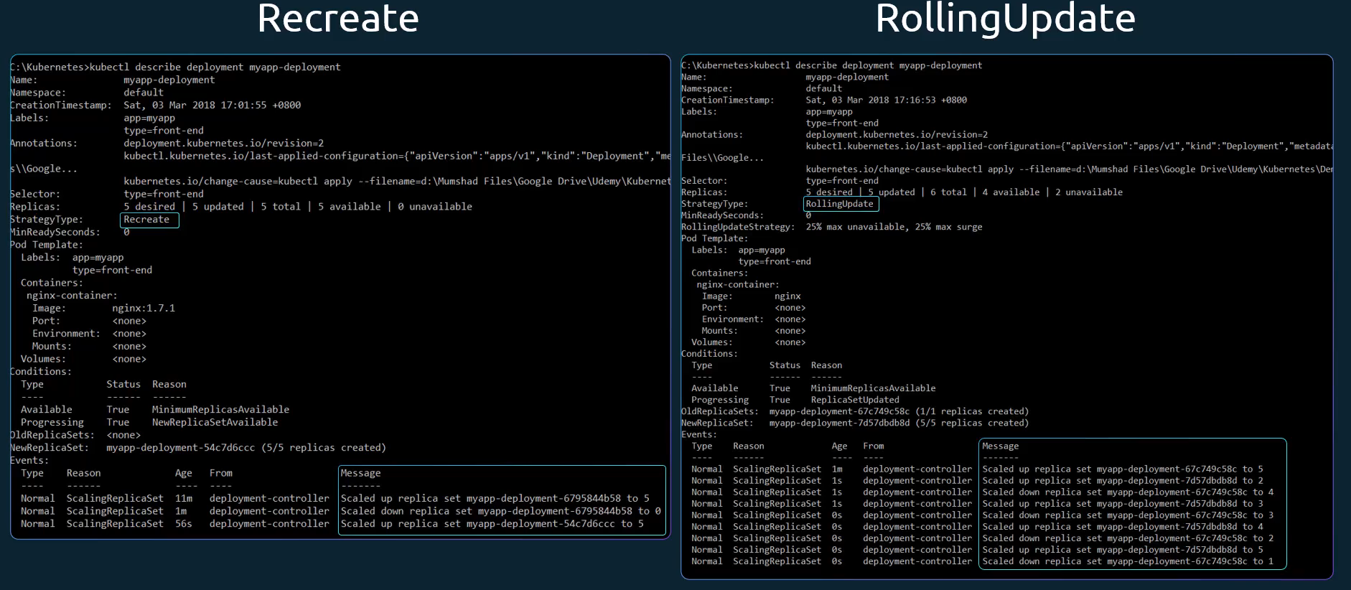
Shadow Deployment
Sends live traffic to both the old and new versions, but only the old version's responses are sent to users. This tests performance with real data without impacting users.

Deployment – Update and Rollback
Before we look at how we upgrade our application, let's try to understand rollouts and versioning in a deployment. When you first create a deployment, it triggers a rollout. A new rollout creates a new replica set, which is recorded as a new deployment revision. In the future when the application is upgraded, meaning when the container version is updated to a new one, a new rollout is triggered and a new deployment revision is created, named revision 2. This helps us keep track of the changes made to our deployment and enables us to roll back to a previous version of deployment if necessary. You can see the status of your rollout by running the command kubectl rollout status, followed by the name of the deployment. To see the revisions and history of rollout, run the kubectl rollout history command followed by the deployment name, and this will show you the revisions and history of our deployment.
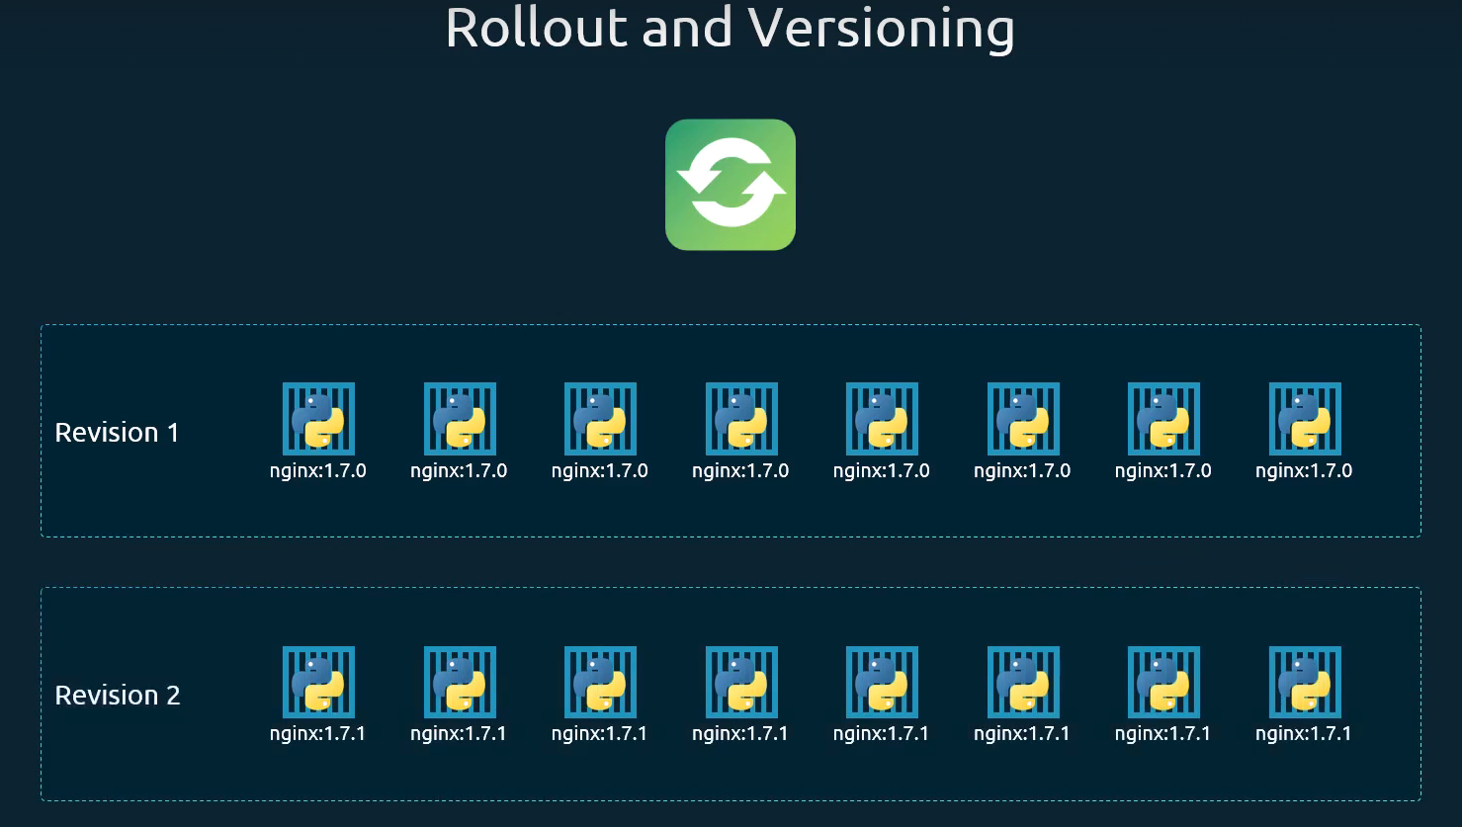
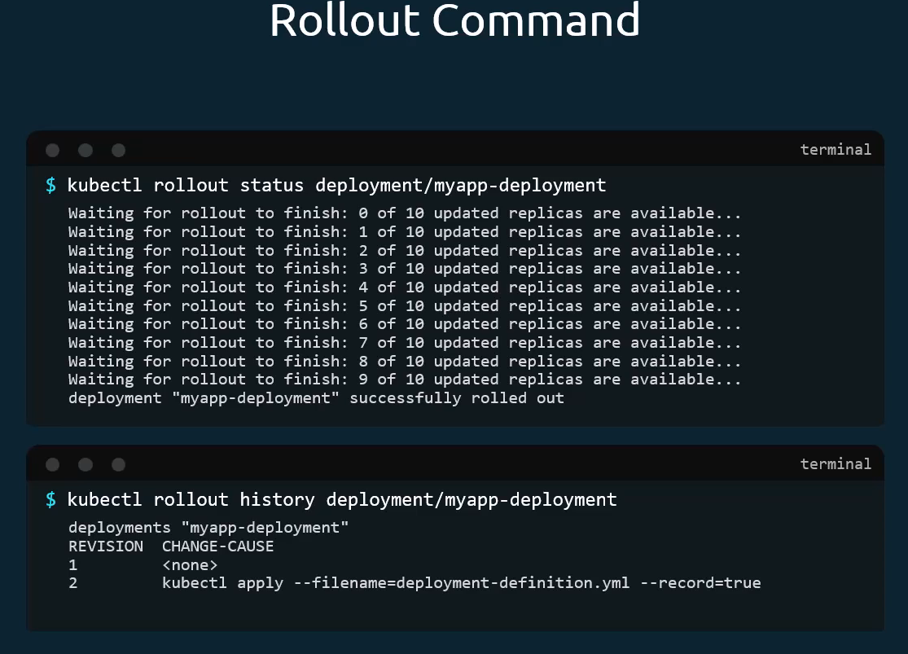
How exactly do you update your deployment? When I say update, it could be different things such as updating your application version by updating the version of Docker containers used, updating their labels or updating the number of replicas etc. Since we already have a deployment definition file, it is easy for us to modify this file. Once we make the necessary changes we can run the kubectl apply command to apply the changes. A new rollout is triggered and a new revision of the deployment is created.
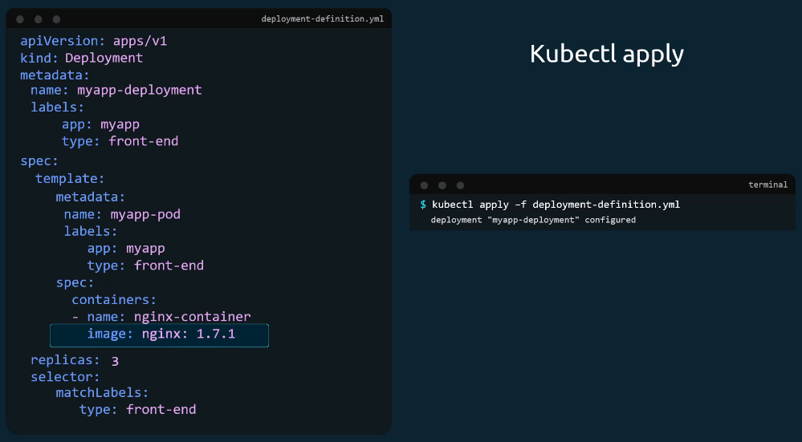
Let's look at how a deployment performs an upgrade under the hood. When a new deployment is created, say, to deploy five replicas, it first creates a replica set automatically, which in turn creates the number of pods required to meet the number of replicas. When you upgrade your application, the Kubernetes deployment object creates a new replica set under the hood and starts deploying the containers there. At the same time taking down the pods in the old replica set following a rolling update strategy. This can be seen when you try to list the replica sets using the kubectl get replicasets command. Here we see the old replica set with zero pods and the new replica set with five parts.
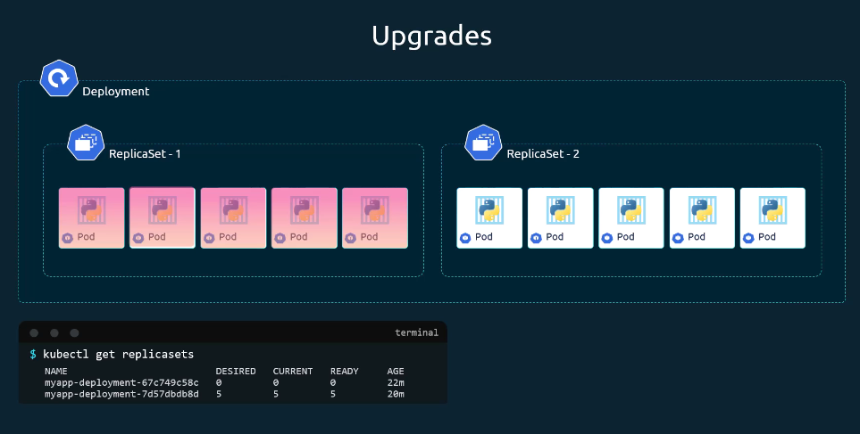
Say for instance, once you upgrade your application, you realize something isn't very right. Something's wrong with the new version of build you used to upgrade. So, you would like to roll back your update. Kubernetes deployments allow you to roll back to a previous revision. To undo a change run the kubectl rollout undo command followed by the name of the deployment. The deployment will then destroy the pods in the new replica set and bring the older ones up in the old replica set, and your application is back to its older format. When you compare the output of the kubectl get replicasets command before and after the rollback. You will be able to notice this difference. Before the rollback the first replica set had zero pods and new replica set had five pods, and this is reversed after the rollback is finished.
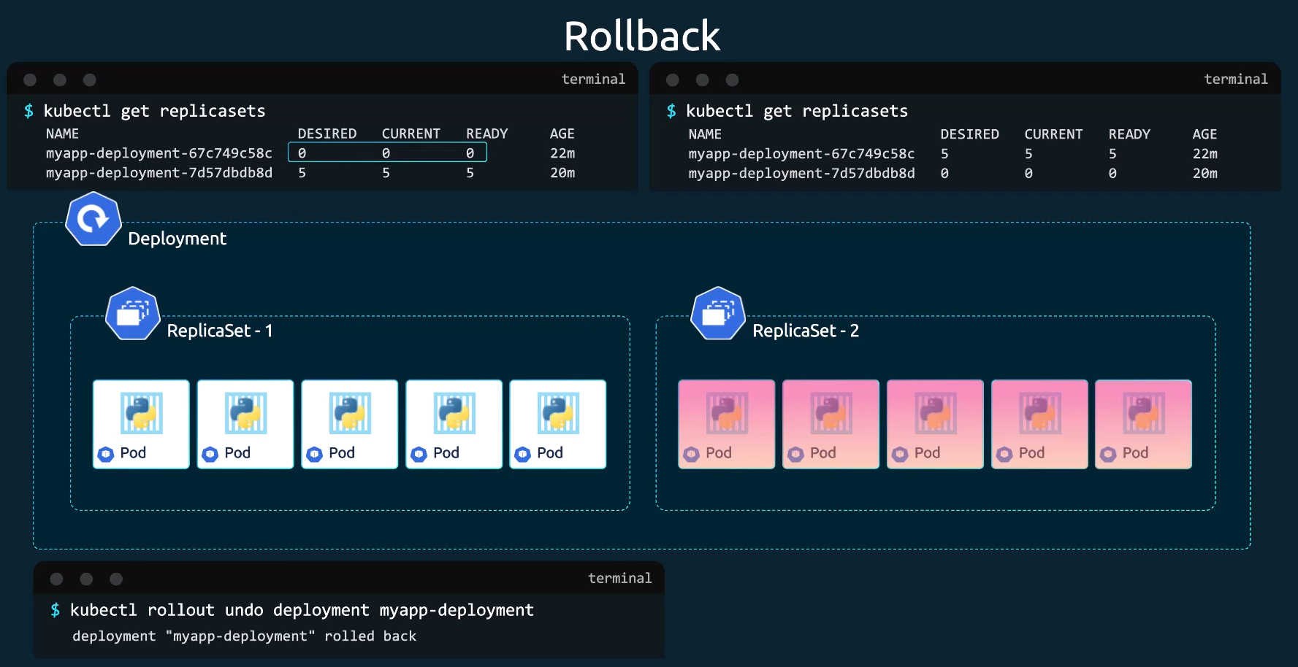
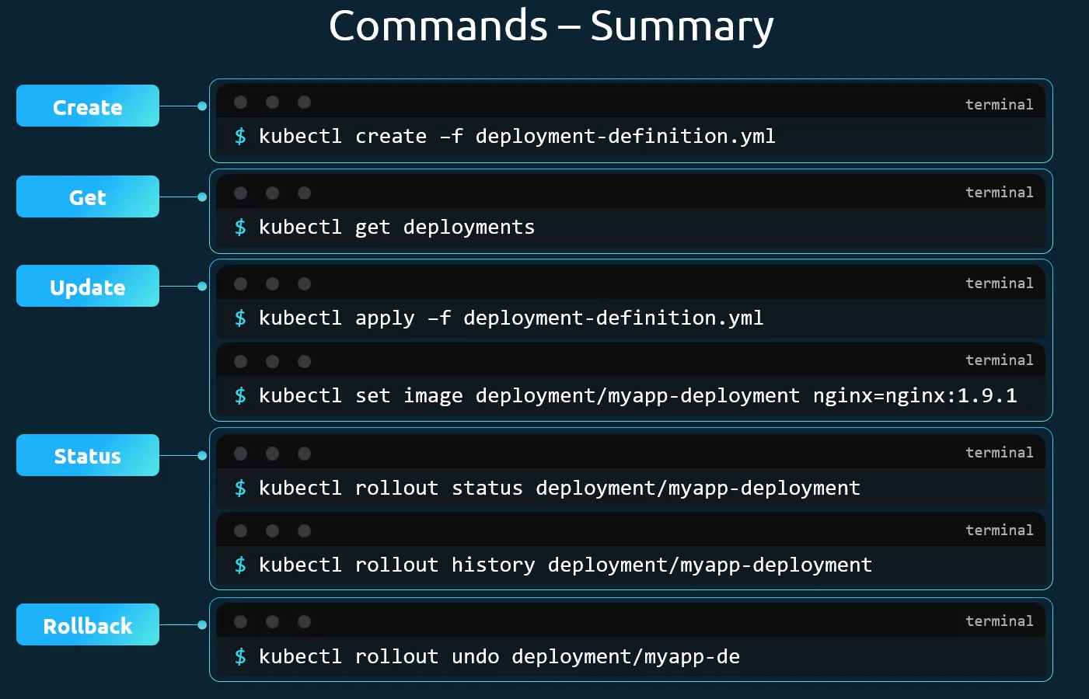
(Note: In the above kubectl set image command, nginx (before the =) is the name of the container defined in the Deployment configuration, and nginx:1.9.1 is the new image)
You can also use following command to update container image, labels, deployment strategy etc. in the deployment
>> kubectl edit deployment <deployment-name>
Replication Controller
A Replication Controller (RC) is a Kubernetes controller that ensures a specified number of Pod replicas are running at all times. In other words, a ReplicationController makes sure that a pod or a homogeneous set of pods is always up and available. Just like a ReplicaSet, its core job is to monitor its managed Pods and automatically create or terminate them to match a desired count. This provides a basic level of fault tolerance and scaling. If there are too many pods, the ReplicationController terminates the extra pods. If there are too few, the ReplicationController starts more pods. Unlike manually created pods, the pods maintained by a ReplicationController are automatically replaced if they fail, are deleted, or are terminated. ReplicationController is often abbreviated to "rc" in discussion, and as a shortcut in kubectl commands.
The replication controller helps us run multiple instances of a single pod in the Kubernetes cluster, thus providing high availability. We can use a replication controller if you plan to have a single pod. Even if you have a single pod, replication controller can help by automatically bringing up a new pod when the existing one fails. Thus, the replication controller ensures that the specified number of pods are running at all times, even if it's just 1 or 100.
Another reason we need replication controller is to create multiple pods to share the load across them. For example, in this simple scenario, we have a single pod serving a set of users. When the number of users increased, we deploy additional pod to balance the load across the two pods. If the demand further increases, and if we were to run out of resources on the first node, we could deploy additional pods across the other nodes in the cluster. As you can see, the replication controller spans across multiple nodes in the cluster. It helps us balance the load across multiple pods on different nodes, as well as scale our application when the demand increases.
Running a single Pod is risky—if it crashes, your application goes offline. A ReplicationController (RC) maintains a specified number of identical Pods, ensuring high availability and load distribution.
The core responsibilities of a Replication Controller are:
- Ensuring High Availability: If a Pod managed by an RC fails, is deleted, or its node crashes, the RC will automatically create a new Pod to replace it, maintaining the desired replica count.
- Scaling: You can manually increase or decrease the number of running Pods by changing the replicas field in the RC's definition. Scaling across nodes to meet growing demand.
- Load Balancing: When used with a Kubernetes Service, an RC enables traffic to be distributed across its set of replica Pods.
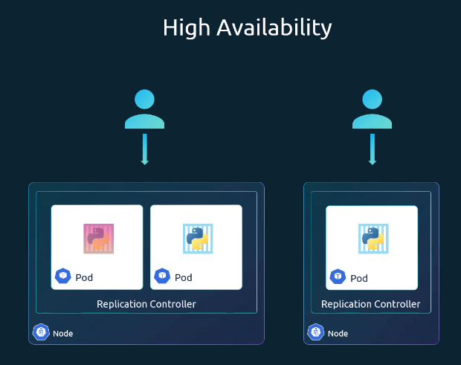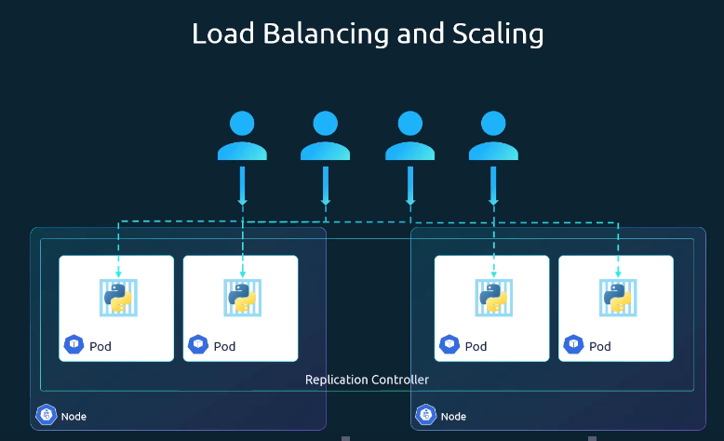

This example ReplicationController config runs three copies of the nginx web server.
replication.yaml
apiVersion: v1
kind: ReplicationController
metadata:
name: myapp-rc
labels:
app: myapp
type: front-end
spec:
replicas: 3
template:
metadata:
name: myapp-pod
labels:
app: myapp
type: front-end
spec:
containers:
- name: nginx-container
image: nginx
ports:
- containerPort: 80

The template section within the Kubernetes ReplicationController's spec defines the blueprint for creating new Pods. It has the same schema as a standalone Pod definition (minus apiVersion and kind), specifying the Pod's metadata and desired state (container images, ports, volumes, etc.). Template section under spec is used to provide a pod template to be used by the replication controller to create replicas.

1) Run the kubectl create or apply command and input the file using -f parameter:
>> kubectl apply -f replication.yaml
The output is similar to this:
replicationcontroller/myapp-rc created
2) When the replication controller is created it first creates the pods using the pod definition template as many as required, which is 3 in this case. To view the list of created replication controllers, run the kubectl get replicationcontroller command and you will see the replication Controller listed. We can also see the desired number of replicas or pods, the current number of replicas, and how many of them are ready in the output.
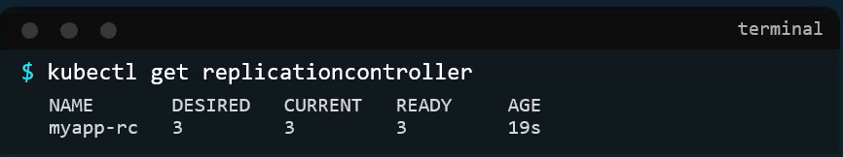
3) If you would like to see the pods that were created by the replication controller, run the kubectl get pods command and you will see three pods running. Note that all of them start with the name of the replication controller, which is myapp-rc, indicating that they are all created automatically by the replication controller.
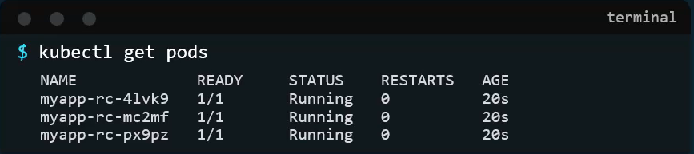
4) Check the detailed state and configuration of the ReplicationController using this command:
>> kubectl describe replicationcontrollers myapp-rc

ReplicaSet:
ReplicationController (RC) is the legacy controller that maintains pod replicas using simple selectors, while ReplicaSet (RS) is its modern replacement with advanced selector support and is used by Deployments. ReplicaSets are the successors to ReplicationControllers. The two serve the same purpose and behave similarly. There is one major difference between replication controller and replica set. Replica set requires a selector definition. The selector in a Kubernetes ReplicaSet is a crucial field that identifies which Pods the ReplicaSet is responsible for managing and maintaining at a desired replica count. The selector section helps the replica set identify what pods fall under it, but why would you have to specify what pods fall under it if we have provided the contents of the pod definition file itself in the template. It's because replica set can also manage pods that were not created as part of the replica set creation. Say for example, the pods created before the creation of the replica set that matched labels specified in the selector. The replica set will also take those pods into consideration when creating the replicas.
The selector is one of the major differences between replication controller and replica set. The selector is not a required field in case of a replication controller, but it is still available when you skip it, it assumes it to be the same as the labels provided in the Pod definition file. In case of replica set, a user input is required for this property, and it has to be written in the form of matchLabels as shown in below config file. The matchLabels selector simply matches the labels specified under it to the labels on the pods. The replica set selector also provides many other options for matching labels that were not available in a replication controller.
ReplicaSet is an evolution of the Replication Controller with additional features and flexibility. It allows more expressive pod selectors using the match expressions field, enabling set-based label selection. The current and stable API version for a Kubernetes ReplicaSet is apps/v1. For ReplicationController which was just v1.
A ReplicaSet's purpose is to maintain a stable set of replica Pods running at any given time. As such, it is often used to guarantee the availability of a specified number of identical Pods. Usually, you define a deployment and let that deployment manage ReplicaSets automatically. A ReplicaSet ensures that a specified number of pod replicas are running at any given time. However, a deployment is a higher-level concept that manages ReplicaSets and provides declarative updates to Pods along with a lot of other useful features. Therefore, we recommend using Deployments instead of directly using ReplicaSets.

replicaset.yaml
apiVersion: apps/v1
kind: ReplicaSet
metadata:
name: myapp-replicaset
labels:
app: myapp
type: front-end
spec:
# modify replicas according to your case
replicas: 3
selector:
matchLabels:
app: myapp
type: front-end
template:
metadata:
name: myapp-pod
labels:
app: myapp
type: frontend
spec:
containers:
- name: nginx-container
image: nginx

1) To create a replica set, run the kubectl create command, providing the definition file as input
>> kubectl create -f replicaset.yaml
2) To see the created replicas run the kubectl get replicaset or kubectl get rs command
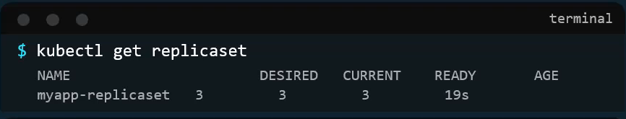
3) To see the list of pods created by the replica set, run the kubectl get pods command and you will see three pods running. Note that all of them are starting with the name of the replica set, which is myapp-replicaset, indicating that they are all created automatically by the replica set.
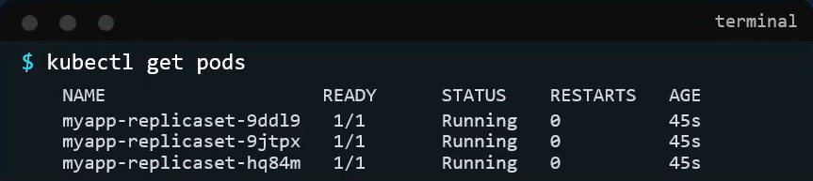
4) Check the detailed state and configuration of the ReplicaSet using this command:
>> kubectl describe rs myapp-replicaset

Labels and Selectors
Why do we label our pods and objects in Kubernetes? Let us look at a simple scenario. Say we deployed three instances of front end web application has three pods. We would like to create a replication controller or replica set to ensure that we have three active pods at any time. And yes, that is one of the use case of replica set. You can use it to monitor existing pods if you have them already created as it is in this example. In case they were not created, the replica set will create them for you. The role of the replica set is to monitor the pods and if any of them were to fail, deploy new ones. The replica set is in fact a process that monitors the pods.
Now, how does the replica set know what pods to monitor? There could be hundreds of other pods in the cluster running different applications. This is where labeling our pods during creation comes in handy. We could now provide these labels as a filter for replica set. Under the selector section, we use the matchLabels filter and provide the same label that we used while creating the pods. This way, the replica set knows which pods to monitor. The same concept of labels and selectors is used in many other places throughout Kubernetes.
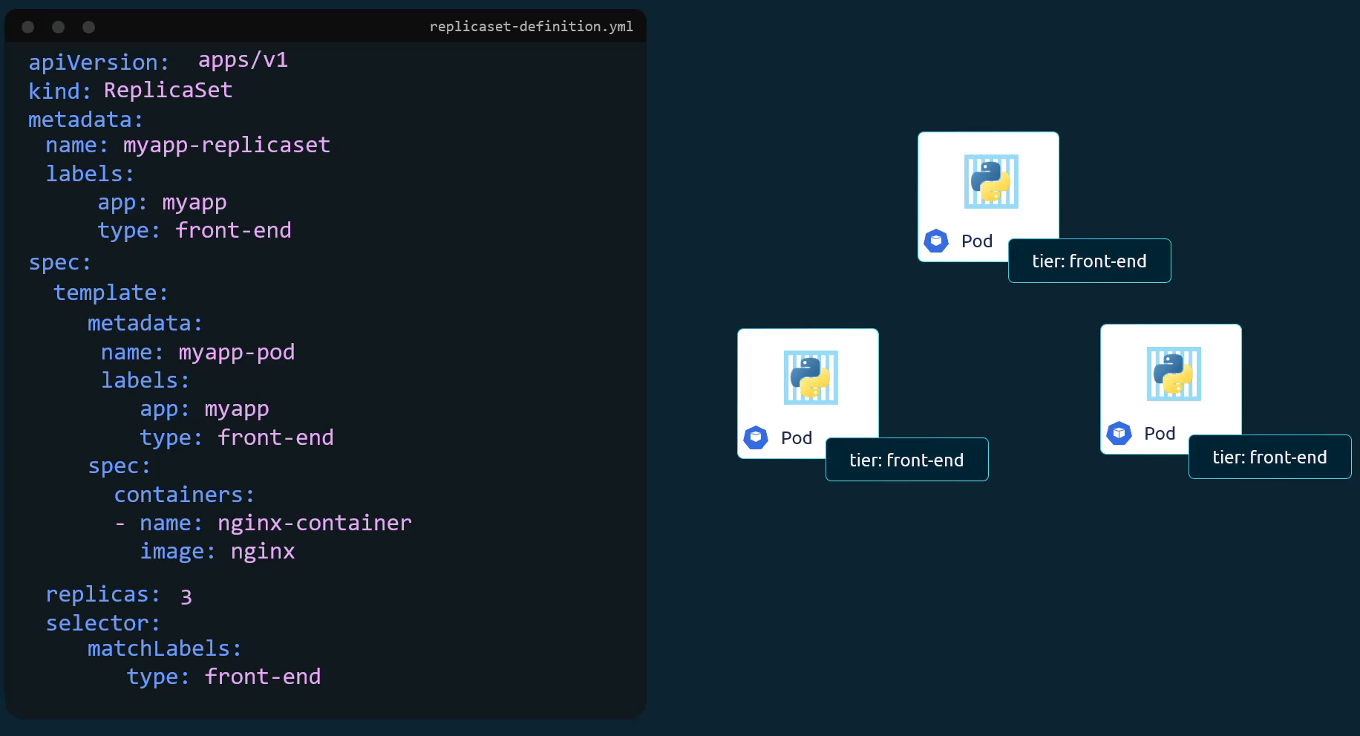
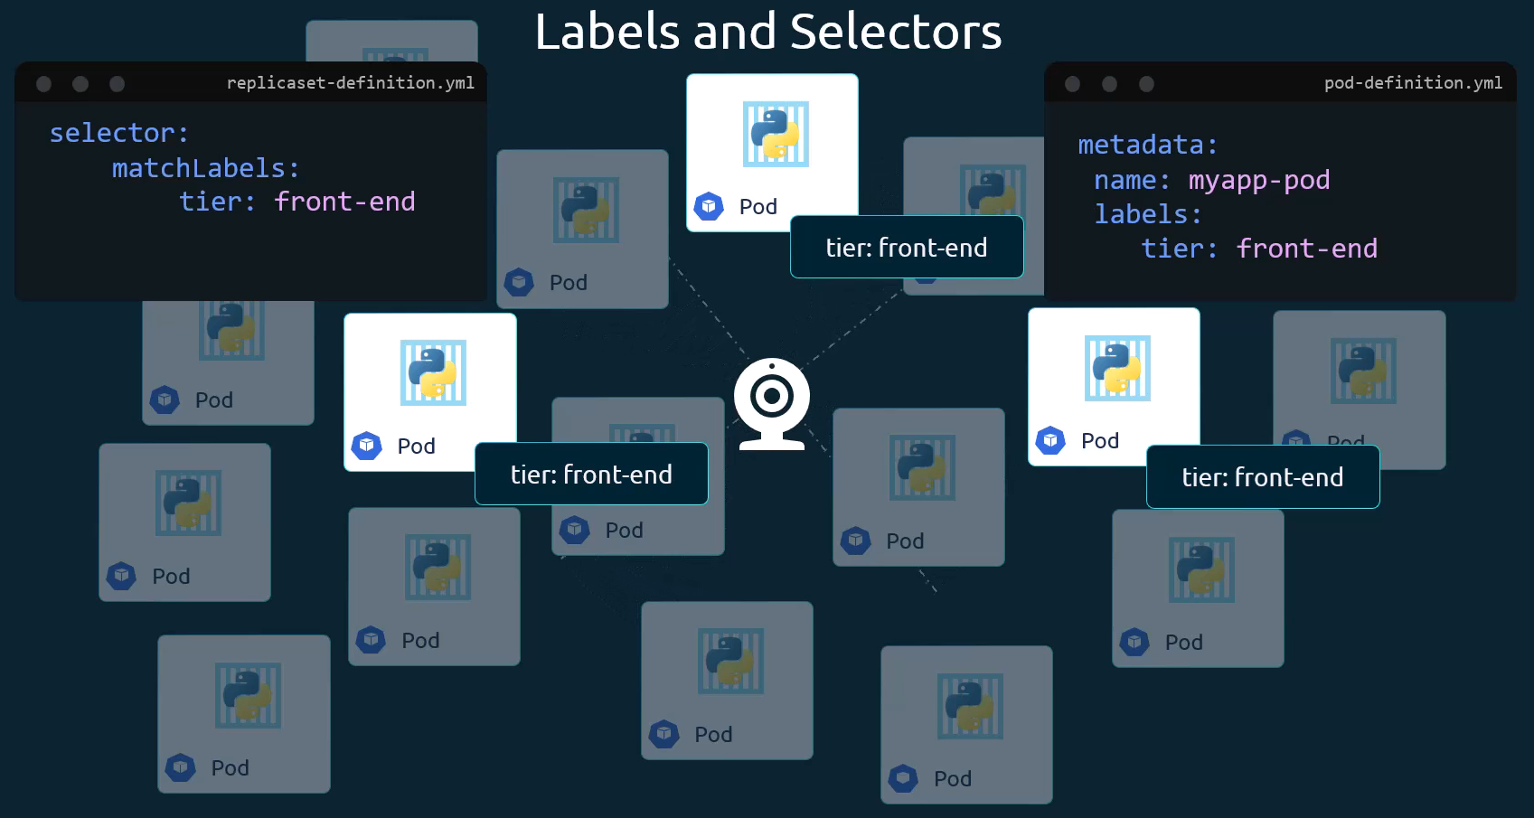
In the replica set specification (spec) section, there are three sections template, replicas and selector. We need three replicas and we have updated our selector as per above discussion. Say for instance, we have three existing pods that were created already. And we need to create a replica set to monitor the pods to ensure there are a minimum of three running at all times. When the replica set is created, it is not going to deploy a new instance of Pod as three of them with matching labels are already created. In that case, do we really need to provide a template section in the replica set specification? Since we are not expecting the replica set to create a new pod on deployment? Yes, we do. Because in case one of the pods were to fail in the future, the replica set needs to create a new one to maintain the desired number of pods. And for the replica set to create a new pod, the template definition section is required.

Scaling a ReplicaSet
Say we started with three replicas and in future we decided to scale to six. Well, there are multiple ways to do it. The first is to update the number of replicas in the definition file to six, then run the kubectl apply command to specify the same file using the -f parameter, and that will update the replica set to have six replicas. The second way to do it is to run the kubectl scale command. Use the replicas parameter to provide the new number of replicas and specify the same file as input. You may either input the definition file or provide the replica set name in the type name format. However, remember that using the file name as input will not result in the number of replicas being updated automatically in the file. In other words, the number of replicas in the replica set definition file will still be three, even though you scaled your replica set to have six replicas using the Kube control scale command and the file as input.
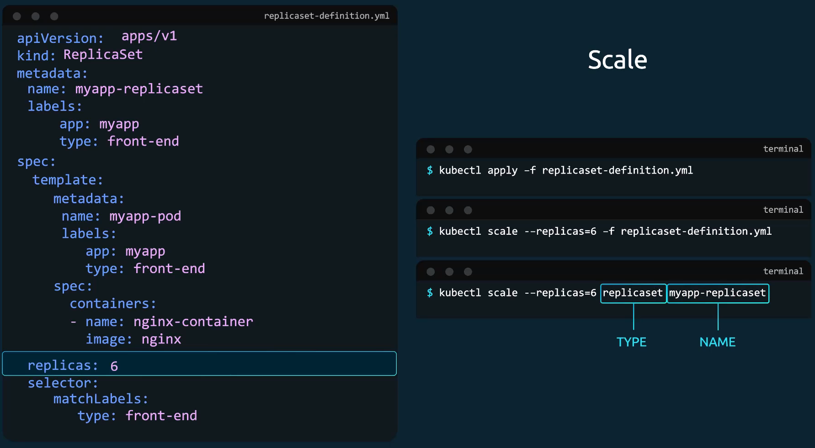

Command sheet sheet
Command | Description
kubectl create -f <file> | Create any Kubernetes object
kubectl get <resource> | List resources (e.g., pods, rs)
kubectl delete <resource> <name> | Delete a resource by name
kubectl replace -f <file> | Update by replacing the manifest
kubectl scale —replicas=<n> -f <file> | Scale replicas from the command line

ReplicationController vs. ReplicaSet
It's important to note that there are two similar terms replication controller and replica set. Both have the same purpose, but they are not the same. Replication controller is the older technology that is being replaced by replica set. Replica set is the new recommended way to set up replication. ReplicationController is the older Kubernetes object used to maintain a stable set of Pods. ReplicaSet is the next-generation replacement for ReplicationController. Both ReplicationController (RC) and ReplicaSet (RS) ensure that a specified number of Pod replicas are running at all times.
While both controllers maintain a set of Pod replicas, ReplicaSet (RS) is the modern API (apps/v1) and supports set-based label selectors. ReplicationController (v1) is older and has fewer selector capabilities. It is recommend using ReplicaSets for new deployments.
Feature | ReplicationController (v1) | ReplicaSet (apps/v1)
API Version | v1 | apps/v1
Selector Support | Equality-based labels only | Equality & set-based label match
Recommended for Usage | Deprecated | Yes

Networking in Kubernetes
Kubernetes network model:
The Kubernetes network model is built out of several pieces:
Each pod in a cluster gets its own unique cluster-wide IP address.
- Pod IP addresses are ephemeral. When a Pod is deleted and recreated, it may receive a different IP. A pod has its own private network namespace which is shared by all of the containers within the pod. Processes running in different containers in the same pod can communicate with each other over localhost.
The pod network (also called a cluster network) handles communication between pods.
- All pods in a Kubernetes cluster can communicate with all other pods, whether they are on the same node or on different nodes. Pods can communicate with each other directly, without the use of proxies or address translation (NAT).
- Agents on a node (such as system daemons, or kubelet) can communicate with all pods on that node.
The Service API lets you provide a stable (long lived) IP address or hostname for a service implemented by one or more backend pods, where the individual pods making up the service can change over time.
- Kubernetes automatically manages EndpointSlice objects to provide information about the pods currently backing a Service.
- A service proxy implementation monitors the set of Service and EndpointSlice objects, and programs the data plane to route service traffic to its backends, by using operating system or cloud provider APIs to intercept or rewrite packets.
The Gateway API (or its predecessor, Ingress) allows you to make Services accessible to clients that are outside the cluster.
- A simpler, but less-configurable, mechanism for cluster ingress is available via the Service API's type: LoadBalancer, when using a supported Cloud Provider.
NetworkPolicy is a built-in Kubernetes API that allows you to control traffic between pods, or between pods and the outside world.

Single-Node Cluster Networking
When Kubernetes is initially configured, the internal private network (Pod network / Cluster network) is created at the cluster level. However, the implementation happens on each node through a CNI (Container Network Interface) plugin. The default Kubernetes pod network CIDR is commonly 10.244.0.0/16 (often used by Flannel). On a single-node cluster, the Kubernetes node itself has an IP address (e.g., 192.168.1.2). You use this address to SSH into the host or connect to the API server. However, each Pod you create is allocated its own IP from a private Pod network—by default, something like 10.244.0.0/16. When you spin up a Pod, Kubernetes assigns it an IP in the 10.244.0.0/16 range, such as 10.244.0.2, which all containers in that Pod share. If you deploy several Pods on this node, each receives a unique IP in the same 10.244.0.0/16 range. They can communicate directly using these IPs.
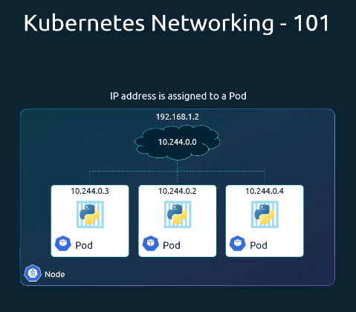

Multi-Node Cluster Networking
As your cluster scales to multiple nodes, each node must have different network address to avoid IP conflicts. If multiple Pods are assigned the same IP address, it will lead to IP conflicts in the network. Each pod deployed has the diff IP address.
Consider two nodes:
Host IP: 192.168.1.2 → Pod subnet 10.244.0.0/24
Host IP: 192.168.1.3 → Pod subnet 10.244.1.0/24

When a Kubernetes cluster is set up, Kubernetes does not automatically set up any kind of networking to handle these issues. As a matter of fact, Kubernetes expects us to set up networking to meet certain fundamental requirements. Some of these are
1) All pods in a Kubernetes cluster can communicate with all other pods without NAT
2) All nodes can communicate with all containers and vice versa without NAT
Kubernetes expects us to set up a networking solution that meets these criteria. Fortunately, we don't have to set it up all on our own as there are multiple pre-built solutions available. Kubernetes’s built-in network support, kubenet, can provide some basic network connectivity. However, it is more common to use third-party network implementations that plug into Kubernetes using the CNI (Container Network Interface) API. Kubernetes lets you use Container Network Interface (CNI) plugins for cluster networking. A CNI plugin is required to implement the Kubernetes network model.
There are lots of different kinds of CNI plugins, but the two main ones are:
- Network plugins, which are responsible for connecting pods to the network
- IPAM (IP Address Management) plugins, which are responsible for allocating pod IP addresses
Some popular CNI plugins are Cisco ACI networks, Cilium, Big Cloud Fabric, Flannel, Weave Net, VMware NSX-T and Calico. Depending on the platform you're deploying your Kubernetes cluster on, you may use one of these solutions.
Without a CNI plugin, Kubernetes does not set up inter-node Pod routing. A CNI plugin handles:
Requirement | Description
Pod-to-Pod | All Pods communicate directly across nodes without NAT
Node-to-Pod | Nodes can reach any Pod IP without SNAT
Pod-to-Node | Pods can reach any node IP address
Non-overlap | Each node gets a unique Pod subnet to prevent IP conflicts

So back to our multi-node cluster with the custom networking either Flannel or Calico setup. It now manages the networks and IPS in the nodes and assigns a different network address for each network in the node. This creates a virtual network of all pods and nodes, where they are all assigned a unique IP address and by using simple routing techniques, the cluster networking enables communication between the different pods or nodes to meet the networking requirements of Kubernetes. Thus, all the pods now can communicate to each other using the assigned IP address. Once your CNI is in place, each node’s CNI daemon (e.g., flanneld or calico-node) allocates a unique /24 Pod subnet and programs the host routes. The result is a seamless overlay network.
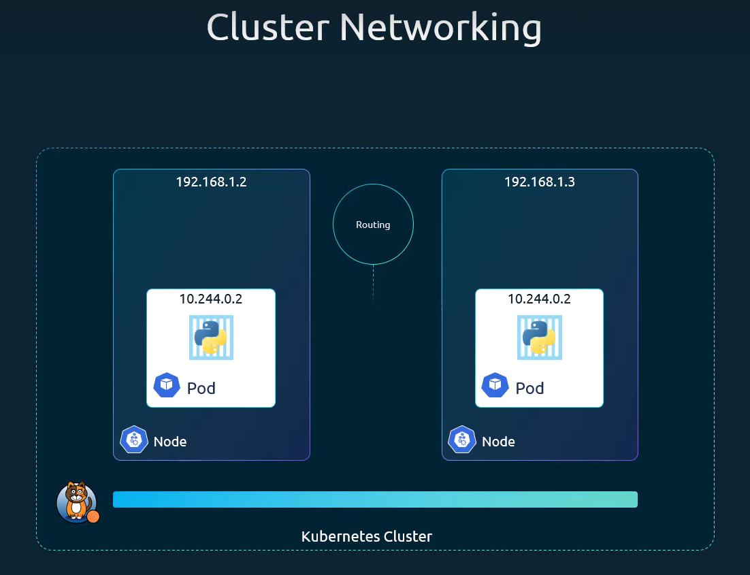

Container Network Interface (CNI)
Kubernetes lets you use Container Network Interface (CNI) plugins for cluster networking. A CNI plugin is required to implement the Kubernetes network model. Controlling networks within Kubernetes clusters is mostly dependent on the Container Network Interface (CNI). CNI is an important component of the Kubernetes environment that allows easy networking and communication between containers and other networks. The CNI plugins are called by the container runtime (like Docker) for setting up the network environment when a pod is created in Kubernetes.
CNI supports Kubernetes networking and is compatible with other Kubernetes-based container management solutions, including OpenShift. CNI uses software-defined networking (SDN) to unify container communication between clusters.

kubenet
Kubernetes’s built-in network support, kubenet, can provide some basic network connectivity. kubenet is a native networking component in Kubernetes that facilitates the management of pod networking in a declarative manner. It relies on Kubernetes API resources and controllers to automate network configurations. Additionally, kubenet is described as a basic network plugin based on the bridge plugin, which includes features like port mapping and traffic shaping, but does not offer cross-node networking by itself.

Service (svc)
A Kubernetes service is a logical abstraction for a deployed group of pods in a cluster (which all perform the same function). When created, each Service is assigned a unique IP address (also called clusterIP). This address is tied to the lifespan of the service and will not change while the service is alive. Since pods are ephemeral, a service enables a group of pods, which provide specific functions (web services, image processing, etc.) to be assigned a name and unique IP address (clusterIP). Services also define policies for their access.
Expose an application running in your cluster behind a single outward-facing endpoint, even when the workload is split across multiple backends. In Kubernetes, a Service is a method for exposing a network application that is running as one or more Pods in your cluster.
A Kubernetes Service is an abstraction that defines a logical set of Pods and a policy by which to access them, providing a stable, persistent IP address and DNS name that remains constant even as individual Pods are created, destroyed, or rescheduled. Services are crucial because Pods are ephemeral and their IP addresses change, making stable communication difficult without this abstraction. A Service provides a consistent, unchanging endpoint for communication, abstracting away the complexities of managing individual Pod IP addresses and performing automatic load balancing across healthy Pods that match a specified label selector.
A service in Kubernetes is a way to connect applications running inside your cluster. It gives your pod a stable way to communicate, even if pods themselves keep changing. Kubernetes services helps us connect applications together with other applications or users. For example, our application has groups of pods running various sections, such as a group for serving a front-end load to users, another group for running back-end processes, and a third group connecting to an external data source. It is services that enable connectivity between these groups of pods. Services enable the front-end application to be made available to end users. It helps communication between backend and frontend pods and helps in establishing connectivity to an external data source. Thus, services enable loose coupling between microservices in our application.
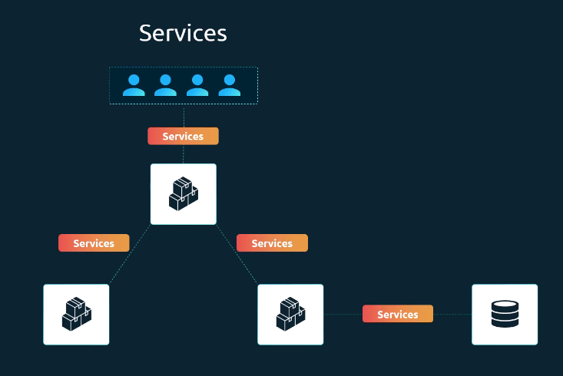
Let's take a look at one use case of services. So, far we talked about how pods communicate with each other through internal networking. Let's look at some other aspects of networking in this lecture. Let's start with external communication. So, we deployed our pod having a web application running on it. How do we as an external user access the web page?
First of all, let's look at the existing setup. The Kubernetes node has an IP address of 192.168.1.2. My laptop is on the same network as well, so it has an IP address 192.168.1.1. The internal Pod network is in the range 10.244.0.0, and the pod has an IP 10.244.0.2. Clearly, I cannot ping or access the pod at address 10.244.0.2 as it's in a separate network. So, what are the options to see the web page? First, if we were to SSH into the Kubernetes node at 192.168.1.2, from the node, we would be able to access the pods web page by doing a curl. Or if the node has a gui, we would fire up a browser and see the web page in a browser following the HTTP 10.244.0.2. But this is from inside the Kubernetes node, and that's not what I really want. I want to be able to access the web server from my own laptop, without having to SSH into the node and simply by accessing the IP of the Kubernetes node.
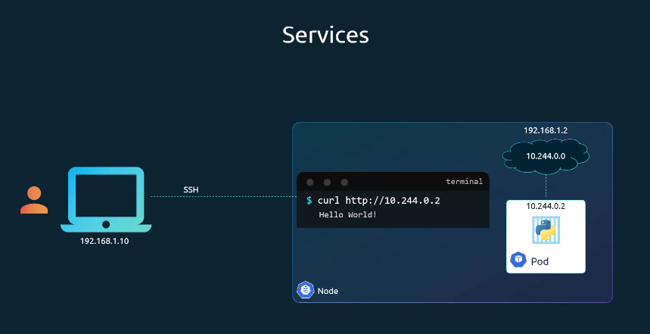
So, we need something in the middle to help us map requests to the node from our laptop, through the node to the pod running the web container. This is where the Kubernetes service comes into play. The Kubernetes service is an object just like pods, replica sets, or deployments. One of its use cases is to listen to a port on the node and forward requests on that port to a port on the pod running the web application. This type of service is known as a node port service, because the service listens to a port on the node and forward requests to the pods.

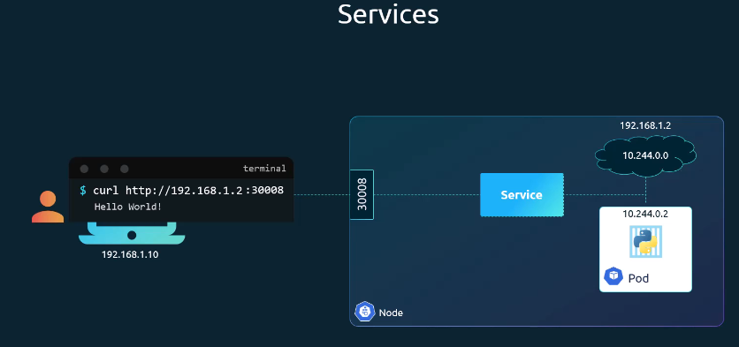

Why Use a Kubernetes Service?
Stable Endpoints: Provides a consistent IP address and DNS name for a set of Pods, so other applications can reliably find and communicate with them.
Service Discovery and Load Balancing: Automatically balances incoming network traffic across healthy Pods that match the service's selector, ensuring high availability and scalability.
Decoupling: Decouples the application from the underlying infrastructure, allowing Pods to scale or move across nodes without impacting communication.

Key Components
Kubernetes services connect a set of pods to an abstracted service name and IP address. Services provide discovery and routing between pods. For example, services connect an application front-end to its backend, each of which running in separate deployments in a cluster. Services use labels and selectors to match pods with other applications. A service configuration file (YAML or JSON) typically includes the following components:
selector: A set of labels (key-value pairs) that determines which Pods are members of the Service. The set of Pods targeted by a Service is usually determined by a selector that you define. Services can be defined without pod selectors. For example, to point a service to another service in a different namespace or cluster.
clusterIP: The stable internal IP address assigned to the Service (or None for a Headless Service).
port: The port number on which the Service itself is exposed.
targetPort: The port number where the containers within the target Pods are listening for traffic.
protocol: The network protocol to use (TCP is the default, UDP and SCTP are also supported).
type: Specifies how the Service is exposed to the network.

Defining a Service
Just like how we created a deployment, replica set or pod in the past. We will use a definition file to create a service. The high level structure of the file remains the same. A Service is an object (the same way that a Pod or a ConfigMap is an object). You can create, view or modify service definitions using the Kubernetes API. Usually, you use a tool such as kubectl to make those API calls for you.
For example, suppose you have a set of Pods that each listen on TCP port 9376 and are labelled as name=MyApp. You can define a Service to publish that TCP listener:
simple-service.yaml
apiVersion: v1
kind: Service
metadata:
name: my-service
spec:
selector:
name: MyApp
type: front-end
ports:
- protocol: TCP
port: 80
targetPort: 9376

Applying this manifest creates a new Service named "my-service" with the default ClusterIP service type. Cluster IP is the default type. So even if you didn't specify it, it will automatically assume the type to be cluster IP. To check, simply execute kubectl get svc, and it will list the available services. The Service targets TCP port 9376 on any Pod with the name: MyApp label. Kubernetes assigns this Service an IP address (the cluster IP), that is used by the virtual IP address mechanism.
The controller for that Service continuously scans for Pods that match its selector and then makes any necessary updates to the set of EndpointSlices for the Service.
Note: A Service can map any incoming port to a targetPort. By default and for convenience, the targetPort is set to the same value as the port field.

Types of Services
Kubernetes offers different service types to cater to various networking needs:
1) ClusterIP (Default): Exposes a service which is only accessible from within the cluster. ClusterIP is the most common service as well as it is the default type of Service, meaning when you create a service and not specify a type it will automatically take ClusterIP as a type. The ClusterIP service is the default service type in Kubernetes, which is used to expose a service on an IP address internal to the cluster. It makes the service accessible only within the Kubernetes cluster and is used for internal communication between services and pods. It is ideal for internal microservice communication. The service is in fact like a virtual server inside the node. Inside the cluster it has its own IP address and that IP address is called the cluster IP of the service.
A full stack web application typically has different kinds of pods hosting different parts of an application. You may have a number of pods running a front-end web server, another set of pods running a back-end server, a set of pods running a key value store like Redis, and another set of pods. Maybe running a persistent database like MySQL. The web front-end server needs to communicate to the back-end servers, and the back-end servers need to communicate to the database as well as the Redis services, etc. So, what is the right way to establish connectivity between these services. The pods all have an IP address assigned to them, but these IPS as we know, are not static. These pods can go down any time, and new pods are created all the time. And so, you cannot rely on these IP addresses for internal communication between the application. Also, what if the one of the front-end pod need to connect to a back-end service. Which of the backend pod that request will go to? And who makes that decision?
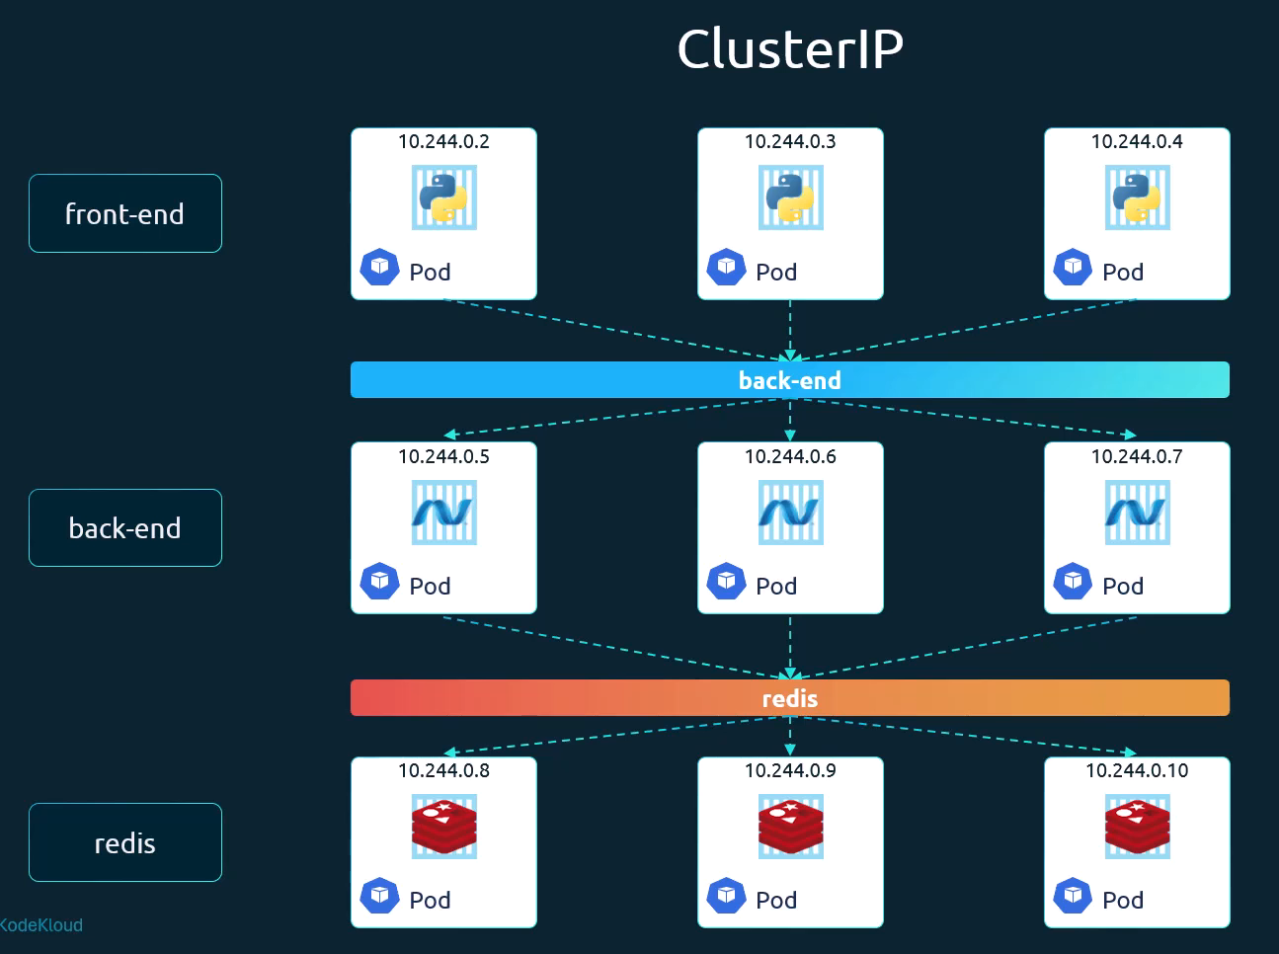
A Kubernetes service can help us group the pods together and provide a single interface to access the pods in a group. For example, a service created for the backend pods will help group all the backend pods together and provide a single interface for other pods to access this service. The requests are forwarded to one of the pods under the service randomly. Similarly, create additional services for Redis and allow the backend pods to access the Redis systems through the service. This enables us to easily and effectively deploy a microservices based application on Kubernetes cluster. Each service gets an IP and name assigned to it inside the cluster, and that is the name that should be used by other pods to access the service. This type of service is known as cluster IP.
To create such a service, as always use a definition file. First use the default template which has API version, kind, metadata and spec. The API version is v1, kind is service. In the metadata section of the configuration, we define a name for the service to uniquely identify it within the Kubernetes cluster. In this case, we will name the service back-end to represent the backend service that the other pods can interact with. Under specification (spec) we have type and ports. The type is cluster IP. In fact, cluster IP is the default type. So even if you didn't specify it, it will automatically assume the type to be cluster IP. Under ports we have a target port and port. The target port is the port where the backend is exposed, which in this case is 80, and the port is where the service is exposed, which is 80 as well. To link the service to a set of ports, we use selector. We will refer to the pod definition file and copy the labels from it and move it under selector.
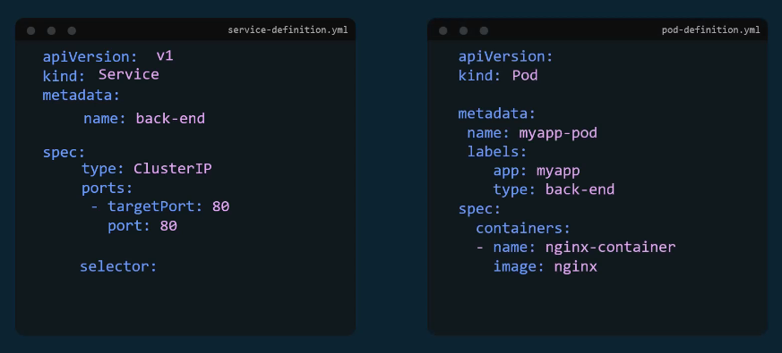
We can now create the service using the kubectl create command and then check its status using the kubectl get services command. The service can be accessed by other pods using the cluster IP or the service name.
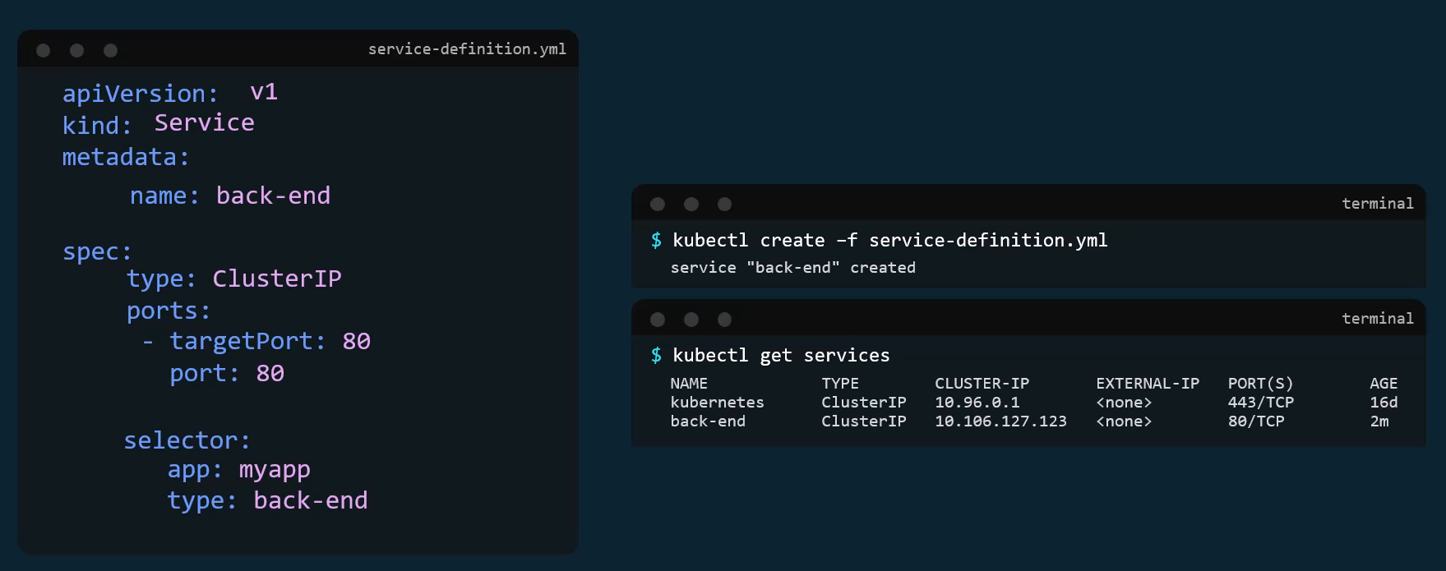

2) NodePort: Exposes a service via a static port on each node’s IP. NodePort is a service that is accessible on a static port on each workernode in the cluster. A NodePort service exposes the application to external clients by opening a specific port (from a range of 30000 to 32767) on all nodes in the cluster. This allows external users to access the application from outside the cluster. The NodePort Service makes the external traffic accessible on static or fixed port on each worker Node which is different from the ClusterIP Service which was only accessible within the Cluster (no external traffic can directly address the ClusterIP Service). The service is accessible from outside the cluster using <NodeIP>:<NodePort>. This is often used for development or testing. NodePort is intended as a foundation for other higher-level methods of ingress such as load balancers and are useful in development. With NodePort instead of Ingress, the browser request will come directly to the worker node at the Port that the service specification defines and the Port that NodePort service type exposes is defined in the NodePort attribute. The NodePort value has a predefined range between 30,000 and 32,767.
The NodePort Service is accessible for the external traffic like browser request. NodePort Service exposure is not very efficient and not secure because we are opening the Ports to directly talk to the Services on each Worker Node so the external clients basically have access to the worker nodes directly, so if we gave all the services this NodePort Service type then we would have a bunch of Ports open on the worker nodes Clients from outside can directly talk to.
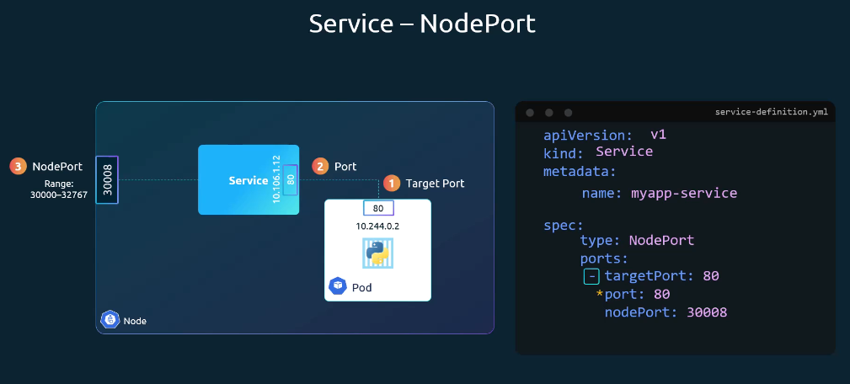
Spec is the most crucial part of the Service config file as this is where we will be defining the actual services. And this is the part of a definition file that differs between different objects. In the spec section of a service, we have type and ports. The type refers to the type of service we are creating. It could be cluster, IP node port or load balancer. The next part of a spec is ports. This is where we input information regarding target port, port and nodeport. Remember that out of these the only mandatory field is port. If you don't provide a target port, it is assumed to be the same as port. And if you don't provide a node port, a free port in the valid range between 30,000 and 32,767 is automatically allocated.
But something is really missing. There is nothing here in the definition file that connects the service to the pod. We have simply specified the target port, but we didn't mention the target port on which pod. There could be hundreds of other pods with web services running on port 80. So, how do we do that? We will use labels and selectors to link these together. We know that the pod was created with a label. We need to bring that label into the service definition file. So we have a new property in the specs section and that is called selector. Just like in a replica set and deployment definition, files under the selector provide a list of labels to identify the pod. For this, refer to the pod definition file used to create the pod. Pull the labels from the pod definition file and place it under the selector section. This links the service to the pod.
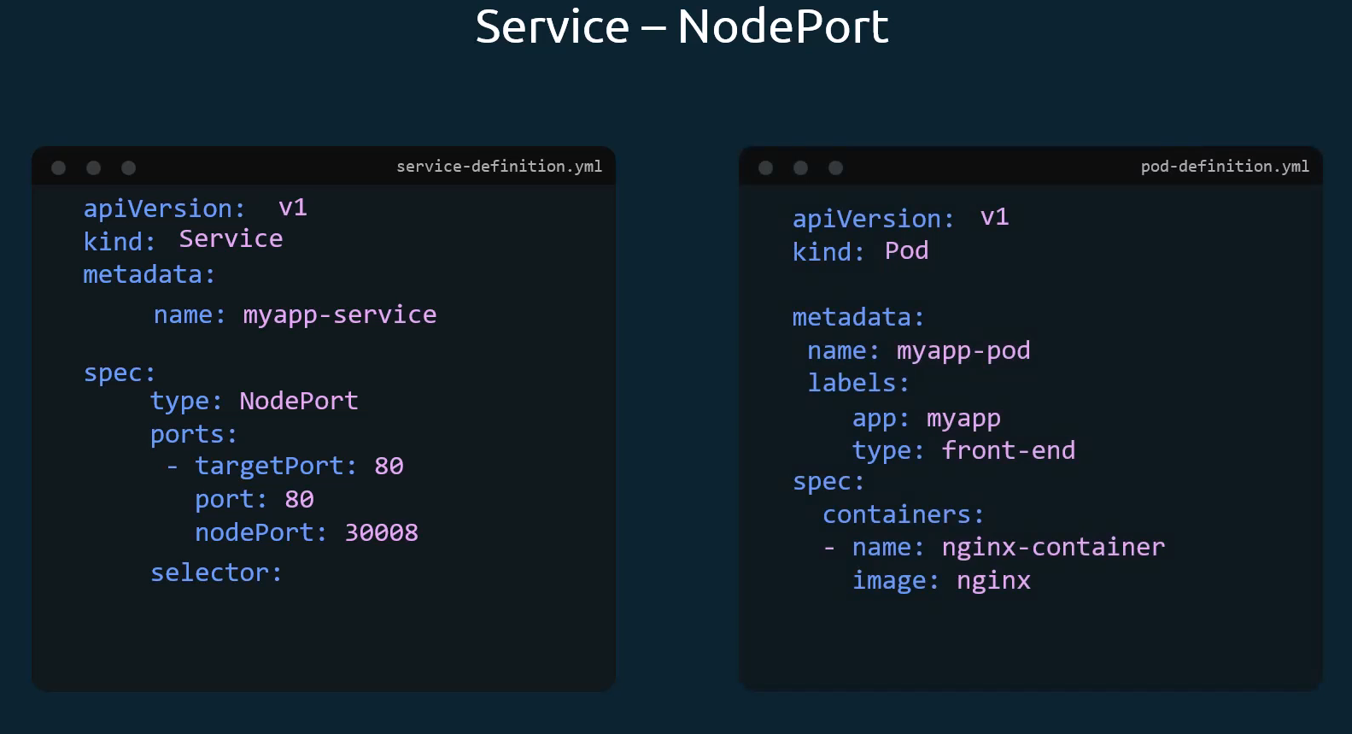
Once done, create the service using the kubectl create command and input the service definition file. To see the created service simply execute kubectl get services or svc command and it will list the available services, cluster IP and the mapped ports. The type is node port as we created and the port on the node is set to 30,008, because that's the port that we specified in the definition file. We can now use this port to access the web service using Curl or a web browser. So, curl to 192.168.1.2 which is the IP of the node and then use the port 30,008 to access the web server.
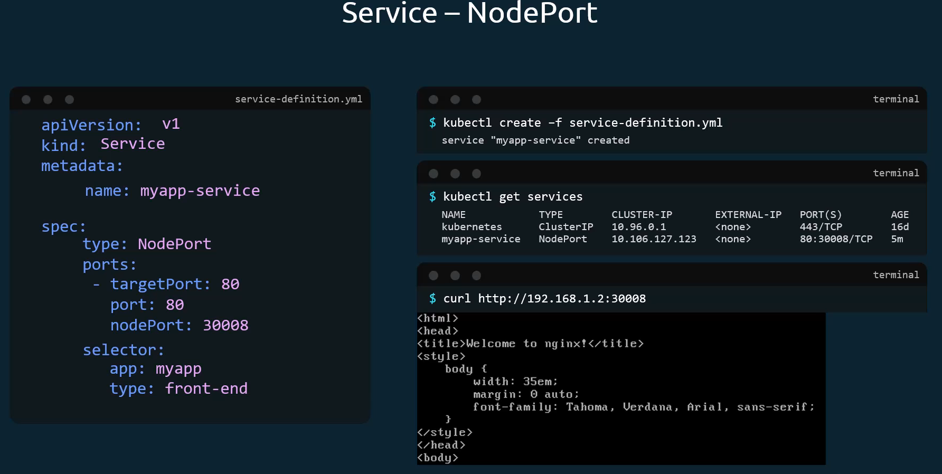
So far we talked about a service mapped to a single pod, but that's not the case all the time. What do you do when you have multiple pods. In a production environment you have multiple instances of your web application running for high availability and load balancing purposes. In this case, we have multiple similar pods running our web application. They all have the same labels with a key app and set to a value of myapp (app: myapp). The same label is used as a selector during the creation of the service. So, when the service is created, it looks for a matching pod with the label and finds three of them. The service then automatically selects all the three pods as endpoints to forward the external requests coming from the user. You don't have to do any additional configuration to make this happen. And if you're wondering what algorithm it uses to balance the load across the three different pods, it uses a random algorithm. Thus, the service acts as a built-in load balancer to distribute load across different pods.
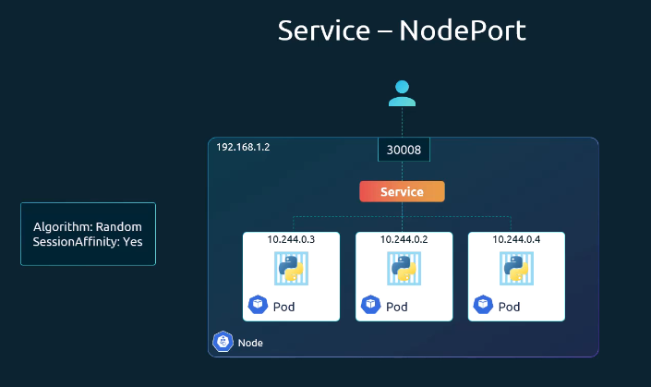
And finally, let's look at what happens when the pods are distributed across multiple nodes. In this case, we have the web application on pods on separate nodes in the cluster. When we create a service without us having to do any additional configuration, Kubernetes automatically creates a service that spans across all the nodes in the cluster and maps the target port to the same node port on all the nodes in the cluster. This way, you can access your application using the IP of any node in the cluster and using the same port number, which in this case is 30,008.
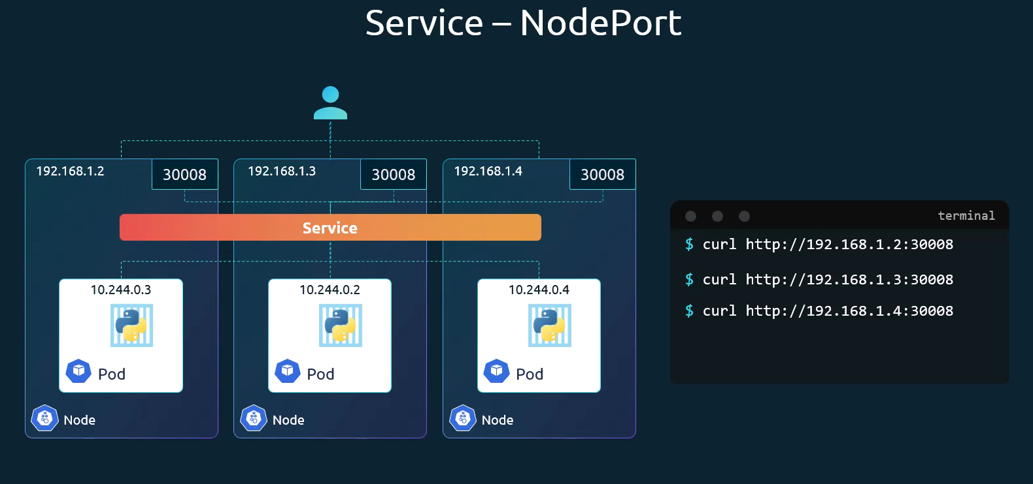
As you can see, using the IP of any of these nodes, and I'm trying to curl to the same port and the same port is made available on all the nodes part of the cluster. To summarize, in any case, whether it be a single pod on a single node, multiple pods on a single node or multiple pods on multiple nodes, the service is created exactly the same without you having to do any additional steps during the service creation. When pods are removed or added, the service is automatically updated, making it highly flexible and adaptive. Once created, you won't typically have to make any additional configuration changes.

To access a NodePort service in a browser or via curl, you need the Node IP and the NodePort
1) Get the NodePort
>> kubectl get svc <service-name>
Example output:
NAME TYPE CLUSTER-IP EXTERNAL-IP PORT(S) AGE
my-service NodePort 10.96.12.34 <none> 80:30007/TCP 5m
Here: Service port = 80 and NodePort = 30007

2) Get the Node IP
>> kubectl get nodes -o wide
Use the INTERNAL-IP (for internal access) or EXTERNAL-IP (for cloud environments).

3) Access the Service
http://<NodeIP>:<NodePort>
Example:
http://192.168.1.10:30007
Using curl: curl http://192.168.1.10:30007
If using Minikube:
>> minikube service <service-name> --url
This directly prints the accessible URL.
minikube runs a single-node Kubernetes cluster on your local machine. It supports multiple container runtimes and works on Linux, macOS, and Windows.
https://minikube.sigs.k8s.io/docs/
https://minikube.sigs.k8s.io/docs/start/?arch=%2Fwindows%2Fx86-64%2Fstable%2F.exe+download
3) LoadBalancer: Exposes the service via the cloud provider’s load balancer. Load Balancer Service type allows the Service to become accessible externally through a Cloud Provider's Load Balancer functionality. LoadBalancer Service is an extension of NodePort Service. All the Cloud Providers like Google Cloud Platform, AWS, Azure, etc. have their own native Load Balancer implementation and that is created and used whenever we create a LoadBalancer Service type. Whenever we create a LoadBalancer Service, NodePort and ClusterIP Services are created automatically by Kubernetes to which the external Load Balancer of the cloud platform will route the traffic to. It provisions an external load balancer, which routes external traffic to the Service. This is the standard choice for production services needing public access.
Here the NodePort which is the port that opens on the Worker Node is not directly accessible externally but only through the Load Balancer. So the entry point becomes a Load Balancer first and it can then direct the traffic to NodePort on the Worker Node and the ClusterIP. Hence we can say that the LoadBalancer Service type is an extension of the NodePort type which itself is an extension of the ClusterIP Service type.
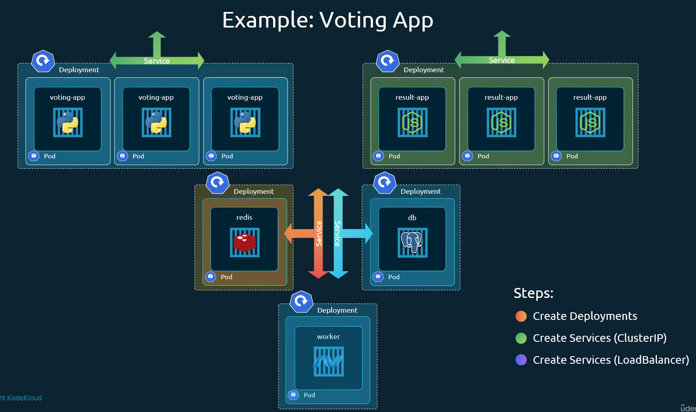
Consider the sample voting application as shown in the picture and turn our focus to the front end applications which are the voting app and the result app. Now we know that these pods are hosted on the worker nodes in a cluster. So let's say we have a four node cluster. And to make the applications accessible to external users we create the services of type node port. Now the services with type node port help in receiving traffic on the ports on the nodes and routing the traffic to the respective pods. But what URL would you give your end users to access the applications? You could access any of these two applications using IP of any of the nodes and the port with the services exposed on. So that would be 4 IP and port combinations for the voting app, and 4 IP and port combination for the result app. Note that even if your pods are only hosted on two of the nodes, they will still be accessible on the IPS of all the nodes in the cluster. Say the pods for the voting app are only deployed on the nodes with IP 70 and 71, they would still be accessible on the ports of all the nodes in the cluster. So that's how a service is configured. So, you would share these URLs to your users to access the application. But that's not what the end users want. They need a single URL like for example-vote.com or the example-result.com to access the application.
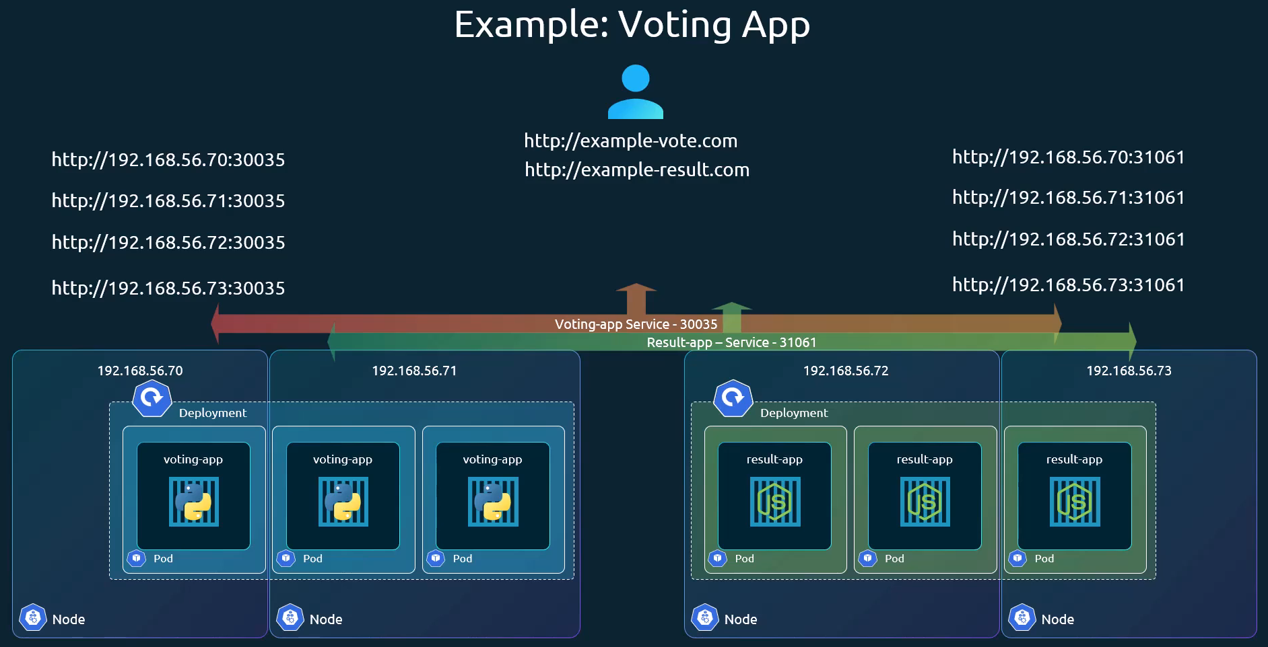
So how do you achieve that? Now one way to achieve this is to create a new VM for load balancer purpose and install and configure a suitable load balancer on it like HAProxy. Or nginx etc. then configure the load balancer to route traffic to the underlying nodes. Now setting all of that external load balancing and then maintaining and managing that can be a tedious task. However, if we were on a supported cloud platform like Google Cloud or AWS or Azure, I could leverage the native load balancer of that cloud platform. So all you need to do is set the service type for the front end services to load balancer instead of Nodeport. Now remember that this only works with supported cloud platforms.
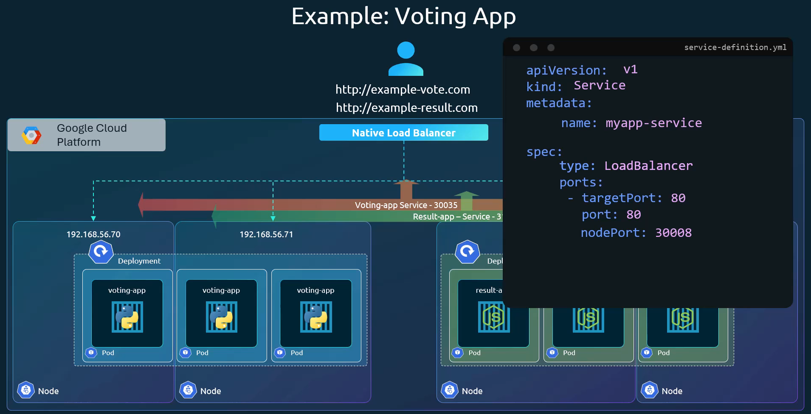
4) ExternalName: Maps the Service to a predefined external DNS name by returning a CNAME record. No proxying is involved, and it's useful for accessing services outside the cluster. Maps a service to a predefined externalName field by returning a value for the CNAME record. ExternalName services are similar to other Kubernetes services; however, instead of being accessed via a clusterIP address, it returns a CNAME record with a value that is defined in the externalName: parameter when creating the service.
Headless: A special type (set clusterIP: None) that does not assign a stable IP address or perform load balancing. Instead, the DNS query for the service name returns the IP addresses of all the backing Pods, allowing clients to connect directly to the Pods. This is often used with StatefulSets or databases.
Headless Service is a type of Service that allows the client to directly communicate with the Pods. It is a useful tool for building distributed applications. Headless Services are used in deploying Stateful Application in Kubernetes.

Use Port Forwarding to Access Applications in a Cluster
Port forwarding in Kubernetes creates a secure, temporary tunnel from a local machine to a specific resource (Pod, Service, Deployment, or ReplicaSet) inside the cluster using the kubectl port-forward command. This allows local access to internal applications for debugging and development without exposing them externally. This will let you access the web server locally, through a tool like curl or a web browser.
While port-forward provides immediate access to the web server, it’s not a permanent solution. The forwarding stops when you terminate the command, and it only works in your local environment—others won't be able to access the web server using this method.
Alternative: Port-forward a Pod (Not Recommended for Production)
>> kubectl port-forward pod/<POD_NAME> 8080:80 -n <namespave_name>
Forwarding from 127.0.0.1:8080 -> 80
Forwarding from [::1]:8080 -> 80
Handling connection for 8080
http://localhost:8080 (open in browser)

Port Forward Command (Recommended – via Service)
>> kubectl port-forward svc/<service_name> 8080:80 -n <namespace_name>
Forwarding from 127.0.0.1:8080 -> 80
Forwarding from [::1]:8080 -> 80
Handling connection for 8080
http://localhost:8080 (open in browser)

Sidecar Containers
Sidecar containers are the secondary containers that run along with the main application container within the same Pod. These containers are used to enhance or to extend the functionality of the primary app container by providing additional services, or functionality such as logging, monitoring, security, or data synchronization, without directly altering the primary application code.
Typically, you only have one app container in a Pod. For example, if you have a web application that requires a local webserver, the local webserver is a sidecar and the web application itself is the app container.
PV, PVC, CRD, RBAC
Virtual Service – Istio (https://istio.io/latest/docs/reference/config/networking/virtual-service/)
A VirtualService defines a set of traffic routing rules to apply when a host is addressed. Each routing rule defines matching criteria for traffic of a specific protocol. If the traffic is matched, then it is sent to a named destination service (or subset/version of it) defined in the registry.
Istio Service mesh (https://istio.io/latest/about/service-mesh/)
Istio is a service mesh—a modernized service networking layer that provides a transparent and language-independent way to flexibly and easily automate application network functions. It is a popular solution for managing the different microservices that make up a cloud-native application. Istio service mesh also supports how those microservices communicate and share data with one another.
Istio addresses the challenges developers and operators face with a distributed or microservices architecture. Whether you're building from scratch, migrating existing applications to cloud native, or securing your existing estate, Istio can help.
Istio is an open source service mesh that helps organizations run distributed, microservices-based apps anywhere. Why use Istio? Istio enables organizations to secure, connect, and monitor microservices, so they can modernize their enterprise apps more swiftly and securely.

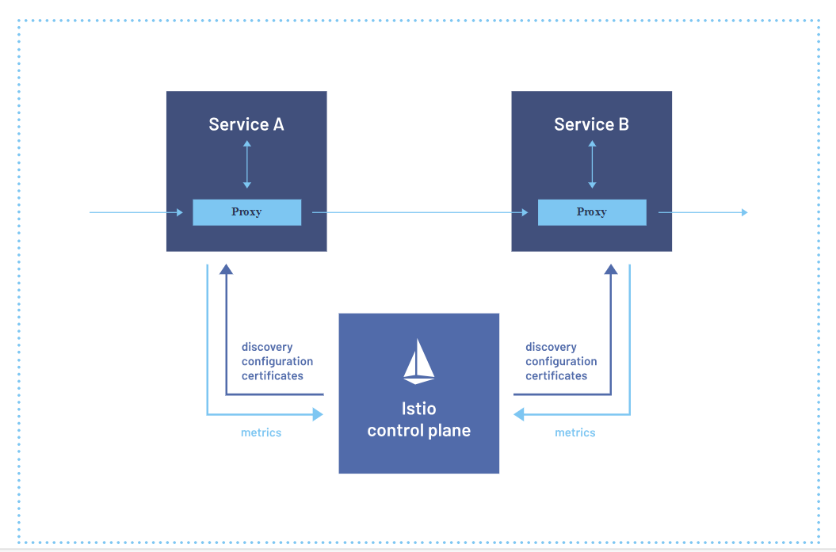
A service mesh is an infrastructure layer that gives applications capabilities like zero-trust security, observability, and advanced traffic management, without code changes. Istio is the most popular, powerful, and trusted service mesh. Founded by Google, IBM and Lyft in 2016, Istio is a graduated project in the Cloud Native Computing Foundation alongside projects like Kubernetes and Prometheus.
Istio ensures that cloud native and distributed systems are resilient, helping modern enterprises maintain their workloads across diverse platforms while staying connected and protected. It enables security and governance controls including mTLS encryption, policy management and access control, powers network features like canary deployments, A/B testing, load balancing, failure recovery, and adds observability of traffic across your estate.
Istio is not confined to the boundaries of a single cluster, network or runtime — services running on Kubernetes or VMs, multi-cloud, hybrid, or on-premises, can be included within a single mesh.

Features
Secure by default
Istio provides a market-leading zero-trust solution based on workload identity, mutual TLS, and strong policy controls. Istio delivers the value of BeyondProd in open source, while avoiding vendor lock-in or SPOFs.
Increase observability
Istio generates telemetry within the service mesh, enabling observability on service behavior. It integrates with APM systems including Grafana and Prometheus to deliver insightful metrics for operators to troubleshoot, maintain, and optimize applications.
Manage traffic
Istio simplifies traffic routing and service-level configuration, allowing easy control over flow between services and setup of tasks like A/B testing, canary deployments, and staged rollouts with percentage-based traffic splits.

Why Istio?
Multiple deployment modes
Istio offers two data plane modes for users to choose. Deploy with the new ambient mode for a simplified app operational lifecycle or with traditional sidecars for complex configurations.
Powered by Envoy
Built on the industry standard gateway proxy for cloud native applications, Istio is highly performative and extensible by design. Add custom traffic functionality with WebAssembly, or integrate third-party policy systems.
A true community project
Istio has been designed for modern workloads and engineered by a vast community of innovators across the cloud native landscape.
Stable binary releases
Confidently deploy Istio across production workloads. All releases are fully accessible at no cost.

Stateful Vs Stateless
Stateless applications are those that do not require persistent data storage or session information between requests. Each request is independent, and the application does not retain information from one request to the next.
- Kubernetes Deployment: The most common way to deploy stateless applications in Kubernetes is using a Deployment object. A Deployment manages a set of identical pods that can be scaled up or down without worrying about the state between them.
- Examples: Web servers, microservices, APIs, and frontend applications that don’t rely on session data.

Stateful applications require persistent storage and need to maintain their state across restarts, which could involve session data, database entries, etc. In Kubernetes, stateful applications are typically deployed using StatefulSets.
- Kubernetes StatefulSet: A StatefulSet is used when you need stable network identities, persistent storage, or ordered pod deployment. It guarantees that each pod gets a unique, stable name and ensures that any persistent data is retained across pod rescheduling (by using PersistentVolumeClaims, or PVCs).
- Examples: Databases (like MySQL, PostgreSQL), message queues (like Kafka), or any application that relies on maintaining session information or data between interactions.

Workload Identity:
Workload Identity is the recommended way to access google cloud services from applications running within GKE due to its improved security properties and manageability. Applications running on GKE must authenticate to use Google Cloud. APIs such as the Compute APIs, storage and database APIs or Machine Learning APIs.
With Workload Identity, you can configure a Kubernetes service account (KSA) to act as a Google Service Account (GSA). Pods running as the KSA will automatically authenticate as the GSA when accessing Google Cloud APIs. This enables you to assign distinct, fine-grained identities and authorization for each application in your cluster.
Kubernetes volume (local, remote(NFS) and cloud storage)
A persistent volume (PV) is storage that exists independently of a container or pod.
Even if the container stops, crashes, or gets deleted, the data stored in the persistent volume remains intact.
Local vs remote storage
Local storage ties data directly to a specific physical node's disk, offering maximum I/O performance and low latency but limiting availability. Remote (network-attached) storage decouples data from the nodes, providing high availability, easy scalability, and fault tolerance, but introduces slight network latency.
PV and PVC
In Kubernetes, a PersistentVolume (PV) is a physical piece of storage in the cluster provisioned by an administrator. A PersistentVolumeClaim (PVC) is a developer’s request to consume that storage. Together, they abstract storage details from application deployment, allowing pods to access stateful data that survives restarts.
A PersistentVolume (PV) is a storage resource in the cluster that has been provisioned by an administrator or dynamically provisioned using Storage Classes.
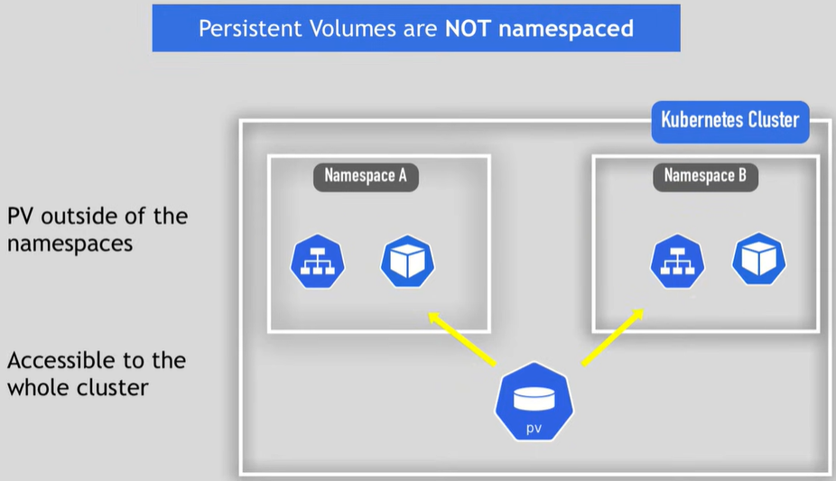
A persistent volume claim (PVC) is a request for storage by a user from a PV. Claims can request specific size and access modes (e.g: they can be mounted once read/write or many times read-only).
If none of the static persistent volumes match the user’s PVC request, the cluster may attempt to dynamically create a PV that matches the PVC request based on storage class.
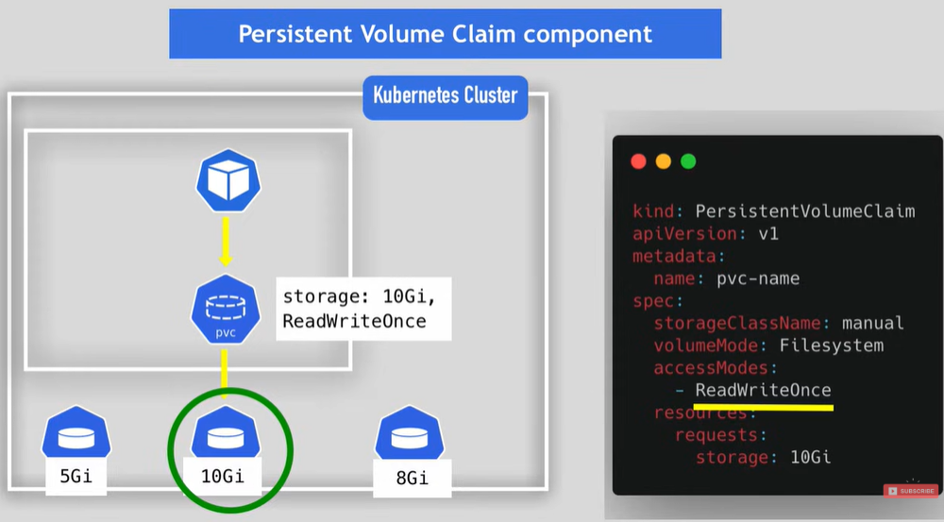
note here that claims must exist in the same namespace as the pod using the claim

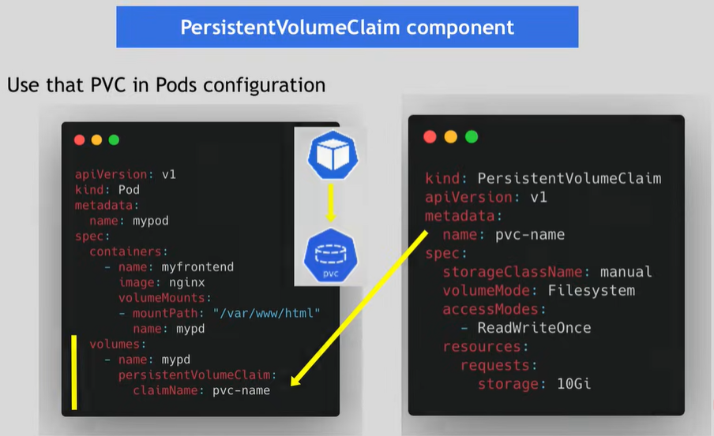
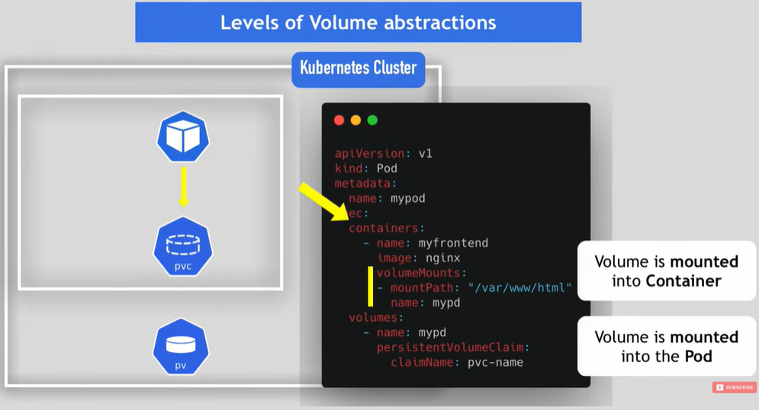

Q) can we create persistent volume in the cluster as a user or we just need to use pvc to claim the already created persitent volumes in the cluster?
Great question — this depends on how your Kubernetes cluster is configured and your permissions.
In Kubernetes, there are two main models:

✅ 1️⃣ Static Provisioning (Admin creates PVs)
How it works
- A cluster admin manually creates PersistentVolumes (PVs).
- Users create PersistentVolumeClaims (PVCs) to request storage.
- Kubernetes binds a matching PV to the PVC.
In this model:
🔒 Regular users typically cannot create PVs.
They can only create PVCs.
Flow:
Admin → creates PV
User → creates PVC
Kubernetes → binds them
This is common in:
- On-prem clusters
- Strictly managed enterprise environments

✅ 2️⃣ Dynamic Provisioning (Most common today)
With StorageClasses, users usually do NOT create PVs manually.
Instead:
- User creates a PVC
- Kubernetes automatically provisions a PV
- A storage backend (like cloud disk, NFS, etc.) creates it
Flow:
User → creates PVC
StorageClass → automatically creates PV
Kubernetes → binds PVC to new PV
This is the default in:
- Managed cloud clusters
- Modern Kubernetes setups

🎯 So what do YOU typically do?
In most real-world clusters:
👉 You only create a PVC
👉 Kubernetes creates the PV automatically
You rarely create PVs manually unless:
- You are cluster admin
- You are using local storage
- Dynamic provisioning is not configured

Lifecycle of a volume and claim
PVs are resources in the cluster. PVCs are requests for those resources and also act as claim checks to the resource. The interaction between PVs and PVCs follows this lifecycle:
Provisioning
There are two ways PVs may be provisioned: statically or dynamically.
Static
A cluster administrator creates a number of PVs. They carry the details of the real storage, which is available for use by cluster users. They exist in the Kubernetes API and are available for consumption.
Dynamic
When none of the static PVs the administrator created match a user's PersistentVolumeClaim, the cluster may try to dynamically provision a volume specially for the PVC. This provisioning is based on StorageClasses: the PVC must request a storage class and the administrator must have created and configured that class for dynamic provisioning to occur. Claims that request the class "" effectively disable dynamic provisioning for themselves.
To enable dynamic storage provisioning based on storage class, the cluster administrator needs to enable the DefaultStorageClass admission controller on the API server. This can be done, for example, by ensuring that DefaultStorageClass is among the comma-delimited, ordered list of values for the --enable-admission-plugins flag of the API server component. For more information on API server command-line flags, check kube-apiserver documentation.
A StorageClass provides a way for administrators to describe the classes of storage they offer. Different classes might map to quality-of-service levels, or to backup policies, or to arbitrary policies determined by the cluster administrators. Kubernetes itself is unopinionated about what classes represent.
The Kubernetes concept of a storage class is similar to “profiles” in some other storage system designs.s
StorageClass objects
Each StorageClass contains the fields provisioner, parameters, and reclaimPolicy, which are used when a PersistentVolume belonging to the class needs to be dynamically provisioned to satisfy a PersistentVolumeClaim (PVC).
The name of a StorageClass object is significant, and is how users can request a particular class. Administrators set the name and other parameters of a class when first creating StorageClass objects.
As an administrator, you can specify a default StorageClass that applies to any PVCs that don't request a specific class. For more details, see the PersistentVolumeClaim concept.

ConfigMap and Secret (Volume types)
both of them are local volumes but unlike the rest these two aren't created by a PV and PVC but a rather own components and managed by Kubernetes itself
Consider a case where you need a configuration file for your Prometheus pod, or maybe for a message broker service like Mosquitto. Another example is when you need to mount a certificate file inside your application. In all these situations, you need a file to be available to your pod. In Kubernetes, this is typically done by creating a ConfigMap or a Secret resource, and then mounting it into your pod and container the same way you would mount a PersistentVolumeClaim.
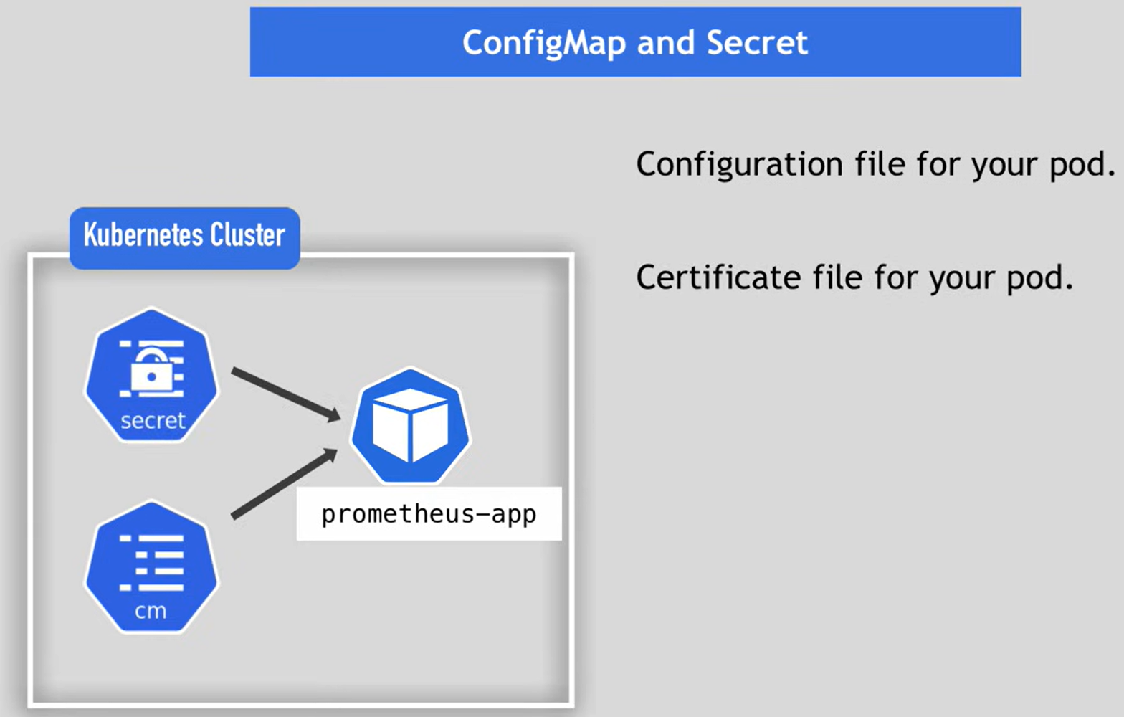
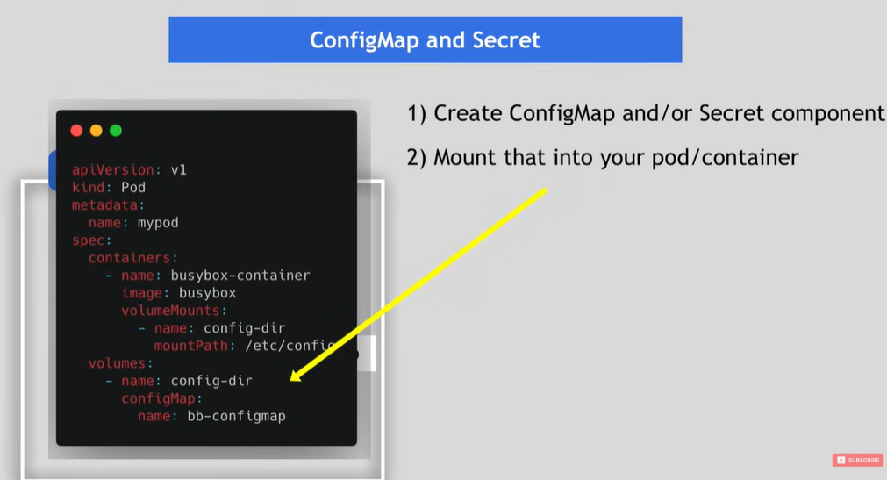

Multi Cluster Gateway or Multi Cluster Ingress
Multi Cluster Ingress is a cloud-hosted controller for Google Kubernetes Engine (GKE) clusters. It's a Google-hosted service that supports deploying shared load balancing resources across clusters and across regions.
Multi Cluster Ingress builds on the architecture of the global external Application Load Balancer.

Landing zone in GCP
A Google Cloud Landing Zone is a pre-configured, secure, and scalable cloud environment that serves as the foundation for deploying and managing enterprise workloads in GCP.
A landing zone, also called a cloud foundation, is a modular and scalable configuration that enables organizations to adopt Google Cloud for their business needs. A landing zone is often a prerequisite to deploying enterprise workloads in a cloud environment.
